Orchardlea Community News

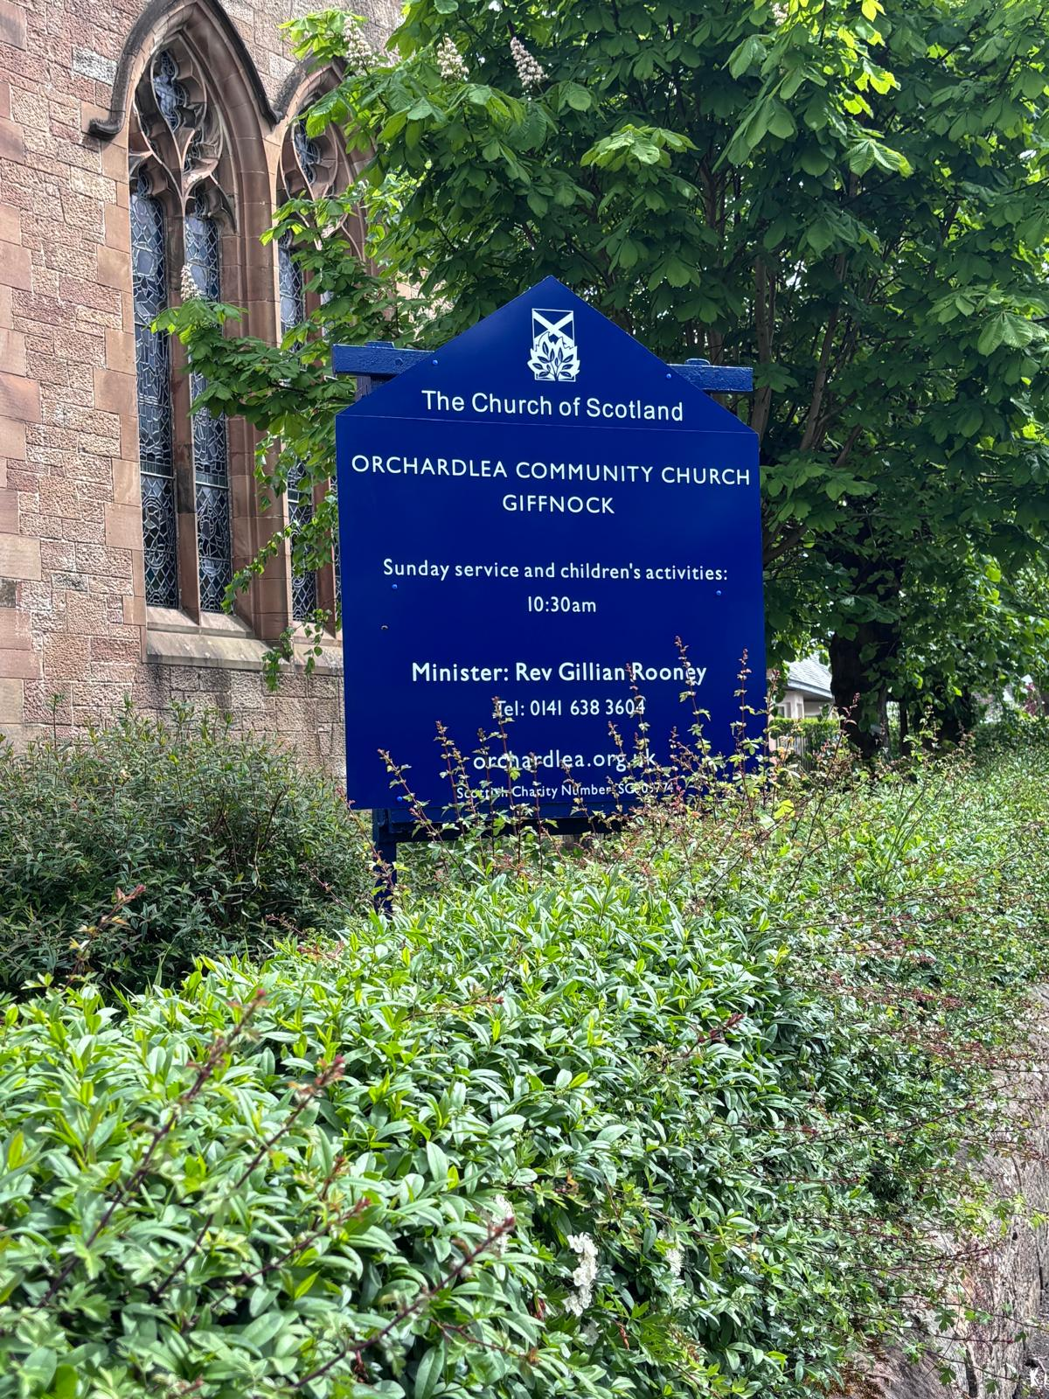

Summer 2026

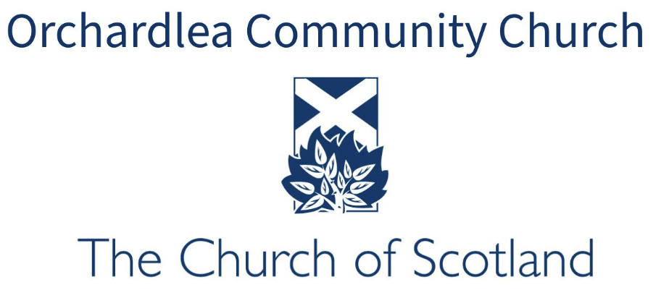

A Word from Gillian Rooney
Dear Friends,

Easter this year began in a wonderfully simple but memorable way. Our early morning service at Orchardhill was originally planned for outdoors, but the weather had other ideas, so we gathered indoors instead. There was something special about being so close together, sharing the joy of the resurrection in a warm and busy sanctuary. It reminded us that church is people, not place.
A few weeks later, on Thursday 7 May, we stepped into a significant new chapter as Orchardhill Parish Church and Merrylea Parish Church united to become Glasgow Orchardlea Community Church. There was both sadness and hope in that moment, as we held onto treasured memories while looking forward with faith to what God is doing among us now. Many of us were moved by the service of union itself, especially Rev Rhona McDonald’s encouraging words about hope for the journey ahead.
Looking ahead, I’m especially excited about our day trip to Culzean Castle in June. It will be a chance to relax, laugh, and deepen friendships as one congregation, and to celebrate all that is growing in this new season together.

We have much to look forward to as a new congregation, together, following Jesus and spreading The Good News.

Yours in Christ,

Gillian

Building Excellence

Church Property Convener Stephen Bennett has achieved an SVQ Level 10 in Construction Management — an honours degree-level qualification — marking an important milestone in his long-standing commitment to personal and professional development.

Stephen was delighted to complete the award, which required him to demonstrate advanced knowledge and practical competence across a wide range of areas, including cost control, project planning, health and safety, leadership, communication, and relationship management.

This achievement brings significant benefits to the church, strengthening the expertise available in overseeing property projects, ensuring compliance with safety standards, supporting effective budgeting, and helping to plan wisely for the future care and development of church buildings and facilities.

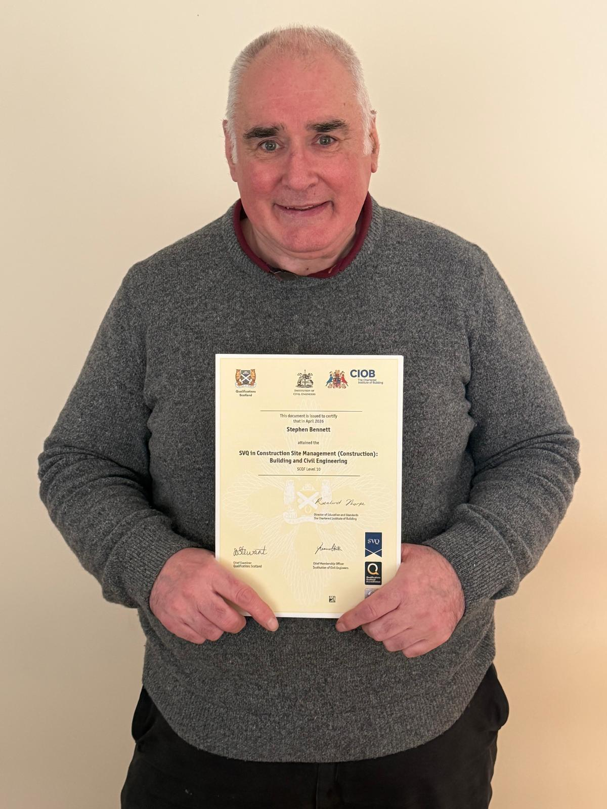

His dedication, professionalism, and willingness to continue learning are a great asset to the church community. Congratulations, Stephen, on this outstanding achievement.

Garden Party Fun

The annual Orchardlea Garden Party, held on 9 May, was a tremendous success, with well over a hundred members of the public coming together for an afternoon of fun, food and community spirit.

Although the weather was a mixed bag of sunshine and rain showers, the event continued in great style throughout the day with people sitting out towards the end as the weather finally allowed.

There was plenty to keep children entertained, including a popular bouncy castle and a tattoo table, both of which were busy throughout the afternoon. Visitors also enjoyed a fantastic selection of refreshments, with hot dogs, cake, teas, coffees and juice available for everyone. Valentini’s ice cream proved especially popular and was a welcome treat during the warmer moments of the day.

The atmosphere remained cheerful all afternoon, with neighbours, families and friends enjoying the welcoming community celebration.

A huge thank you goes to the dedicated events team for organising such a wonderful occasion. Their hard work and commitment were especially appreciated as the garden party took place only two days after the Service of Union. It was truly a great day for everyone involved.

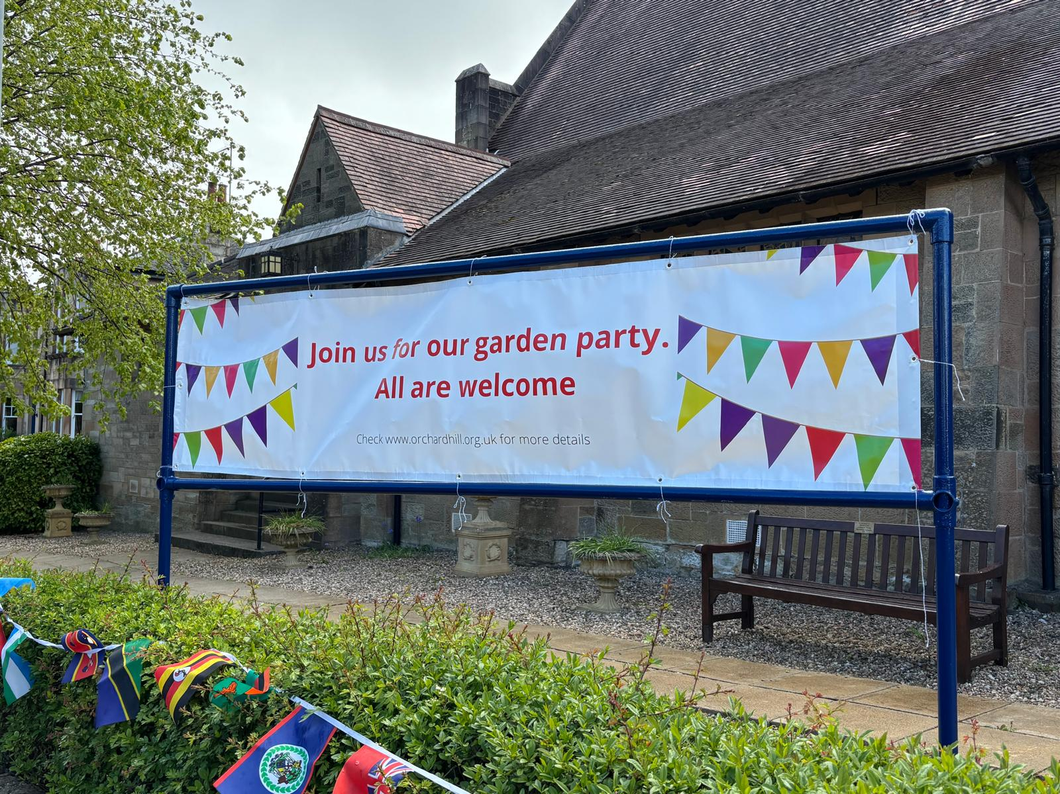

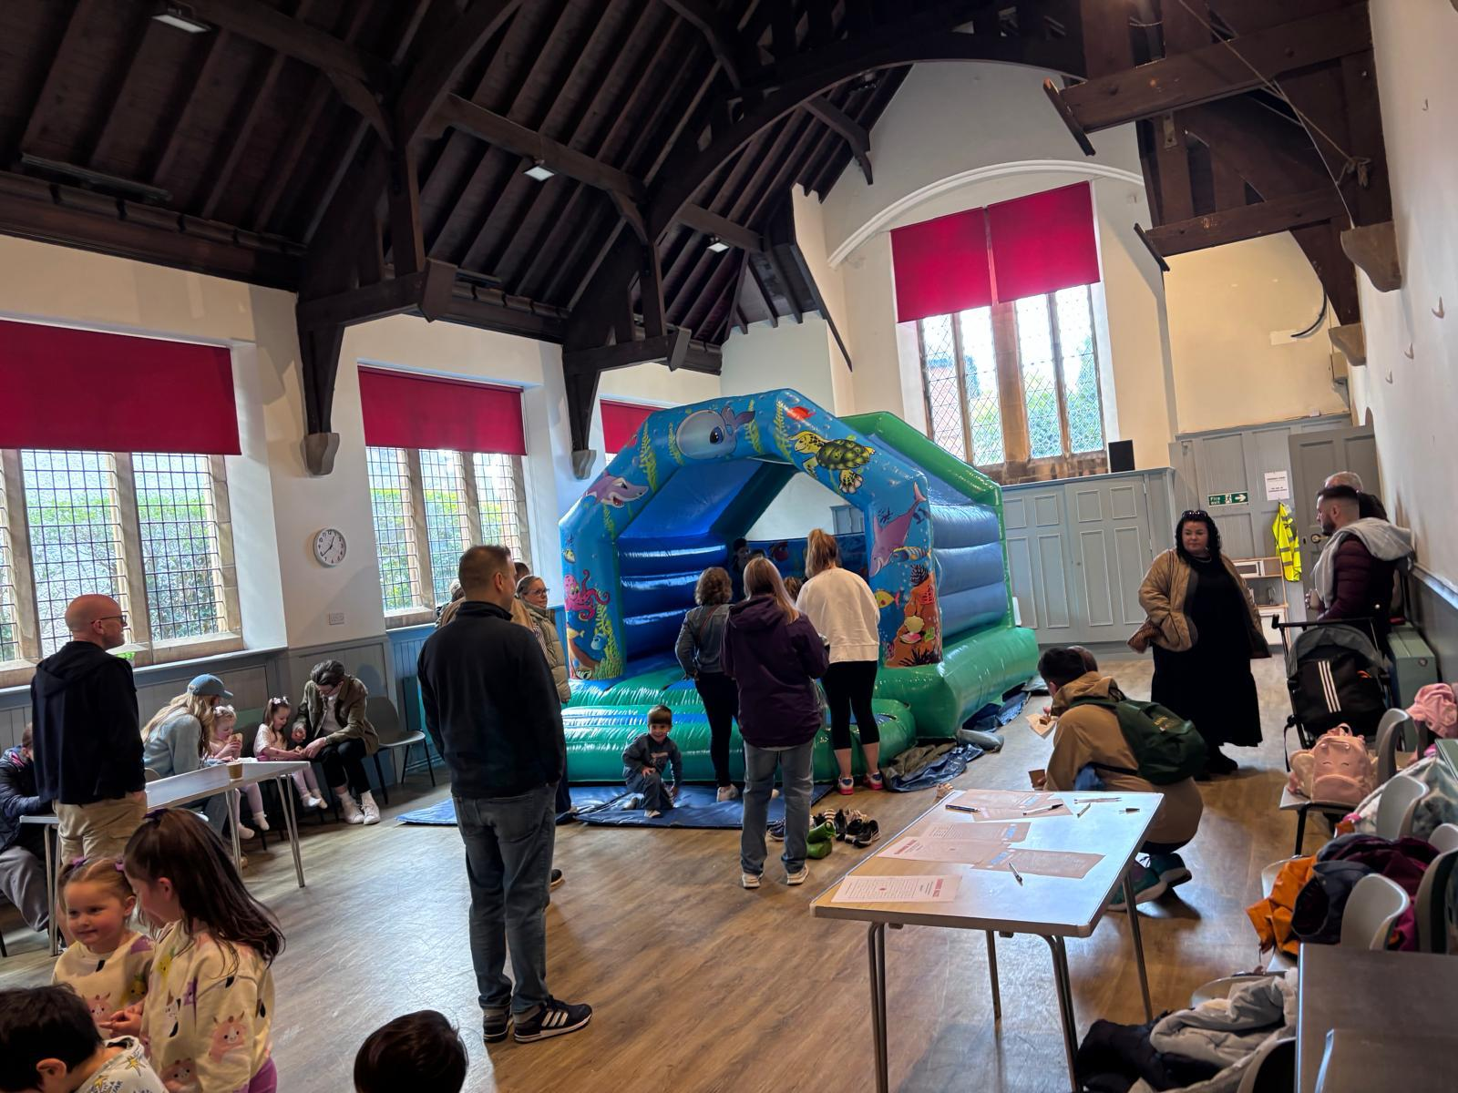

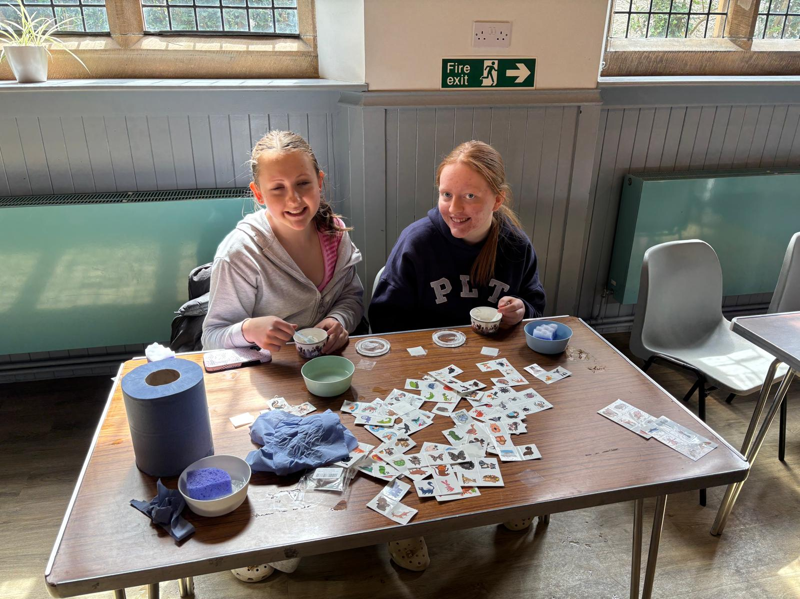

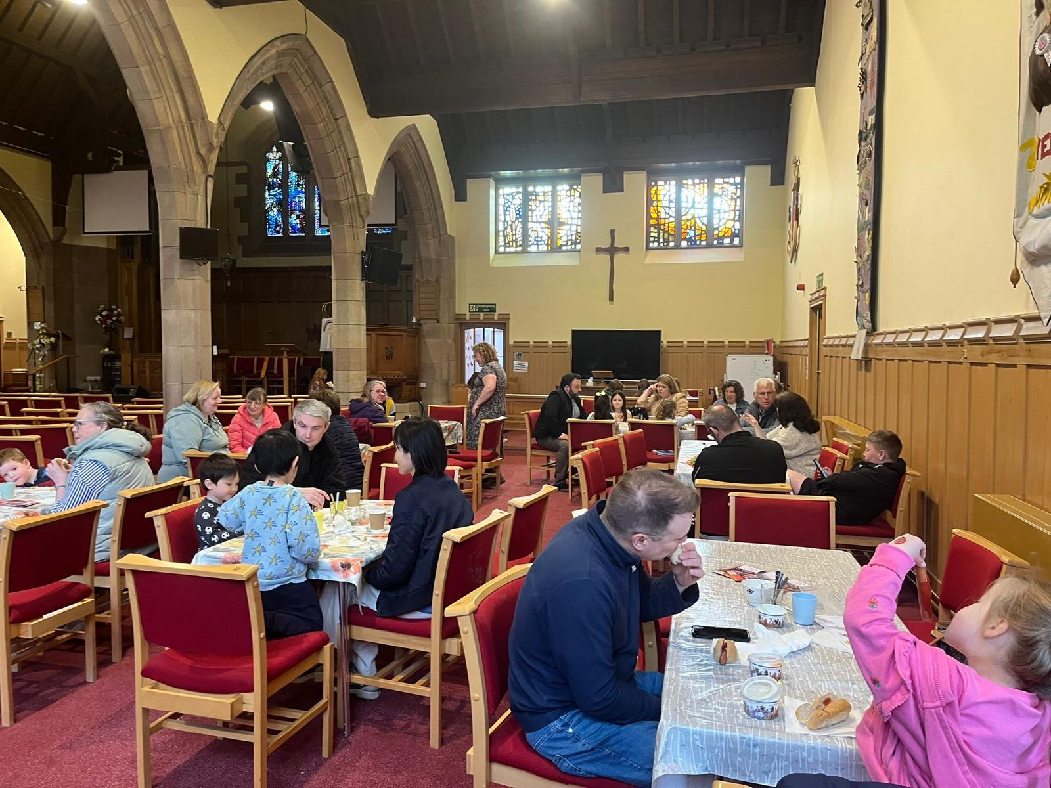

A New Chapter Begins - Glasgow Orchardlea Community Church

On Thursday 7 May 2026, a significant and hopeful new chapter began in the life of the Church in Glasgow as Orchardhill Parish Church and Merrylea Parish Church formally united to become Glasgow Orchardlea Community Church. More than 100 people gathered for the Service of Union, marking both an ending and a beginning for two much-loved congregations with long and faithful histories.

The service was conducted with warmth, dignity and celebration by the officiating clergy: Rev George Mackay, Rev Dr Grant Barclay, Rev Hilary McDougall and Rev Rhona McDonald. Rev McDonald spoke particularly movingly, offering words of encouragement, faith and hope for the future journey of the new congregation.

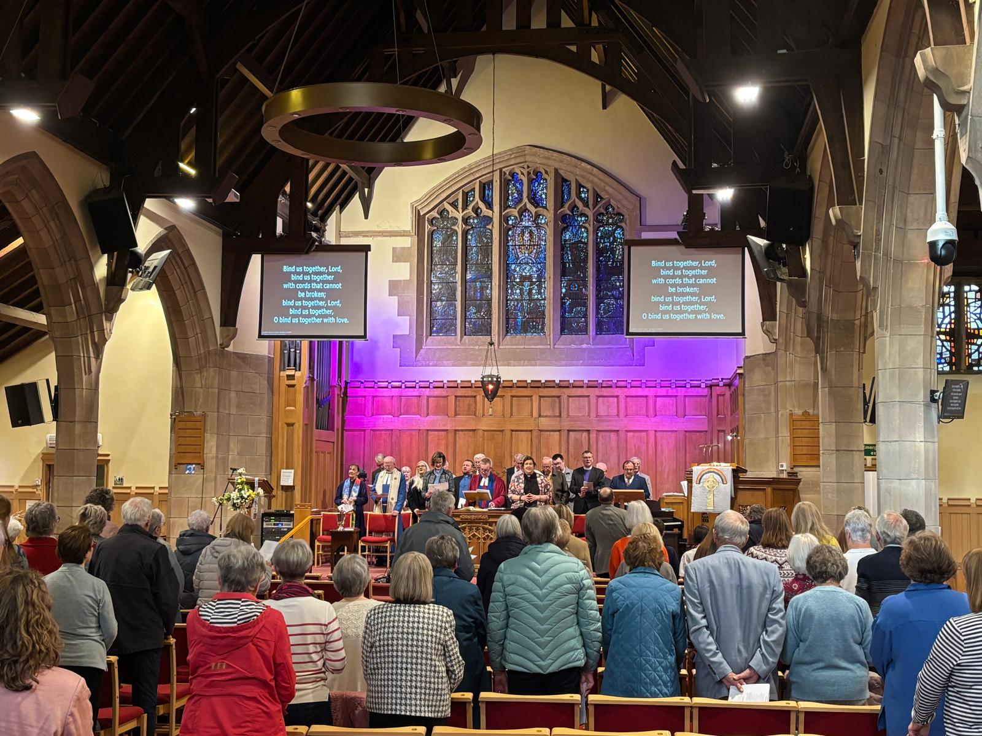

The union followed two emotional final services held on Sunday 3 May in Orchardhill and Merrylea churches. On that day, members shared treasured memories of baptisms, weddings, friendships and faithful worship within their church families. Alongside the fond recollections came heartfelt expressions of optimism for the future, with many speaking warmly about the opportunities that now lie ahead together as one united congregation.

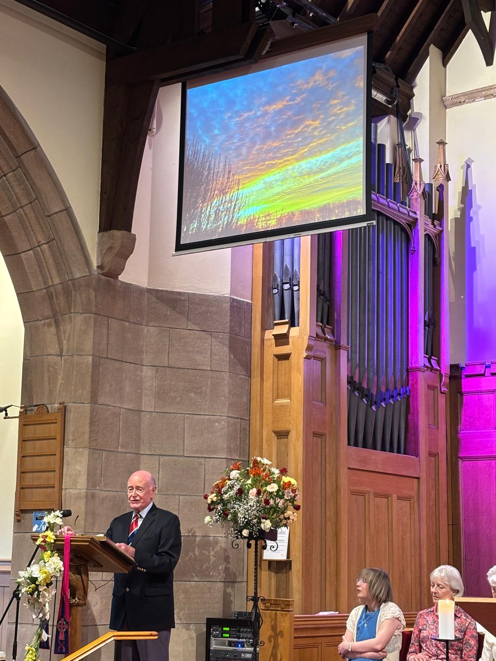
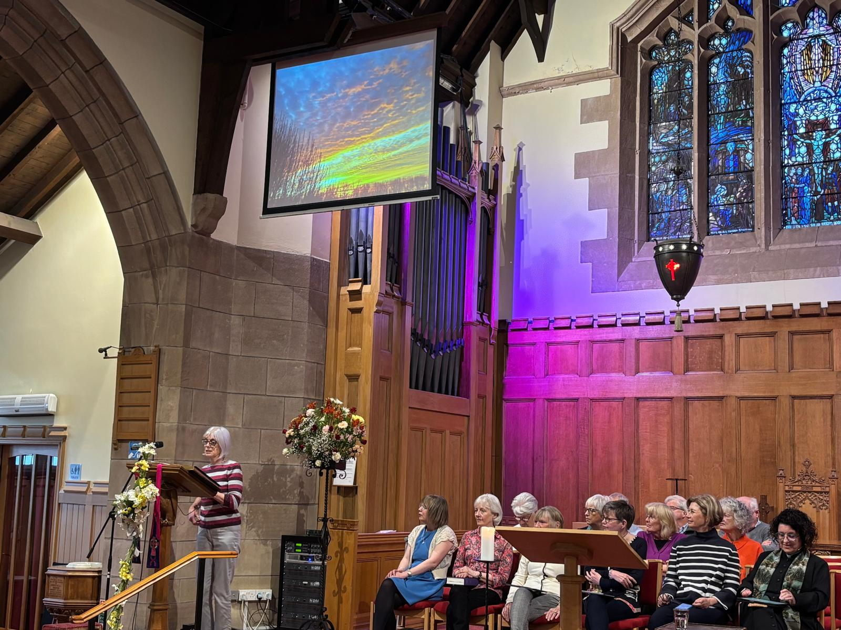

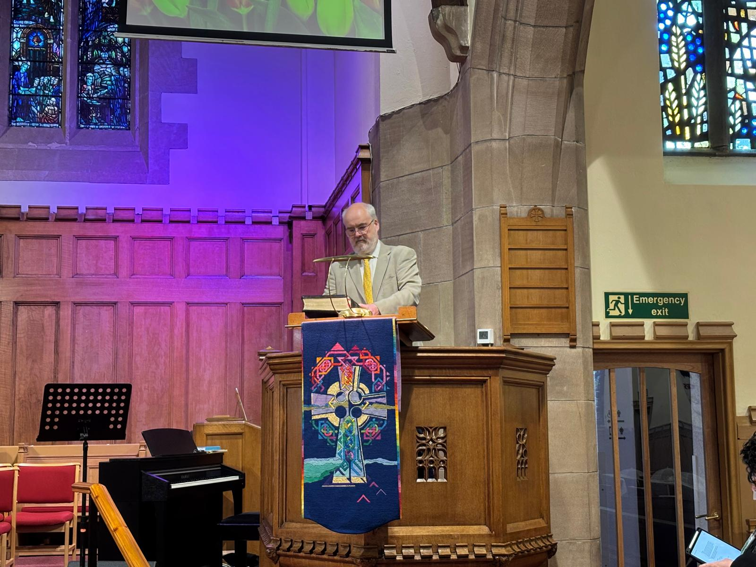

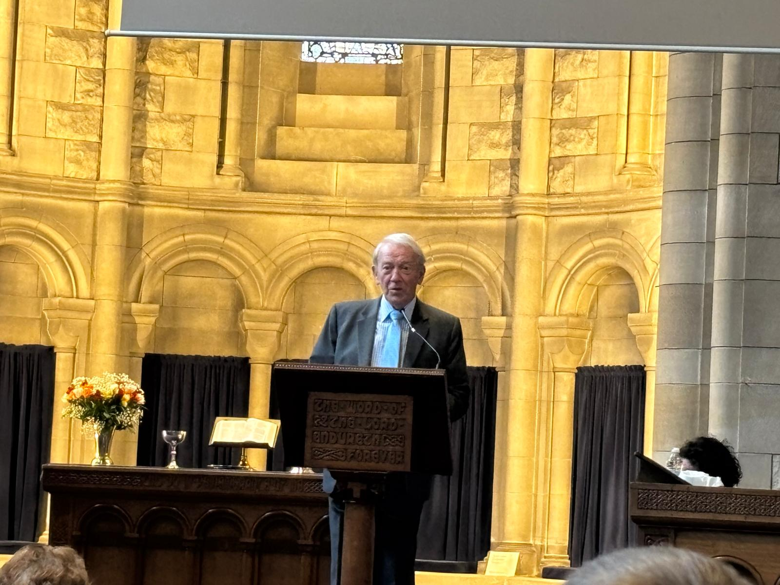
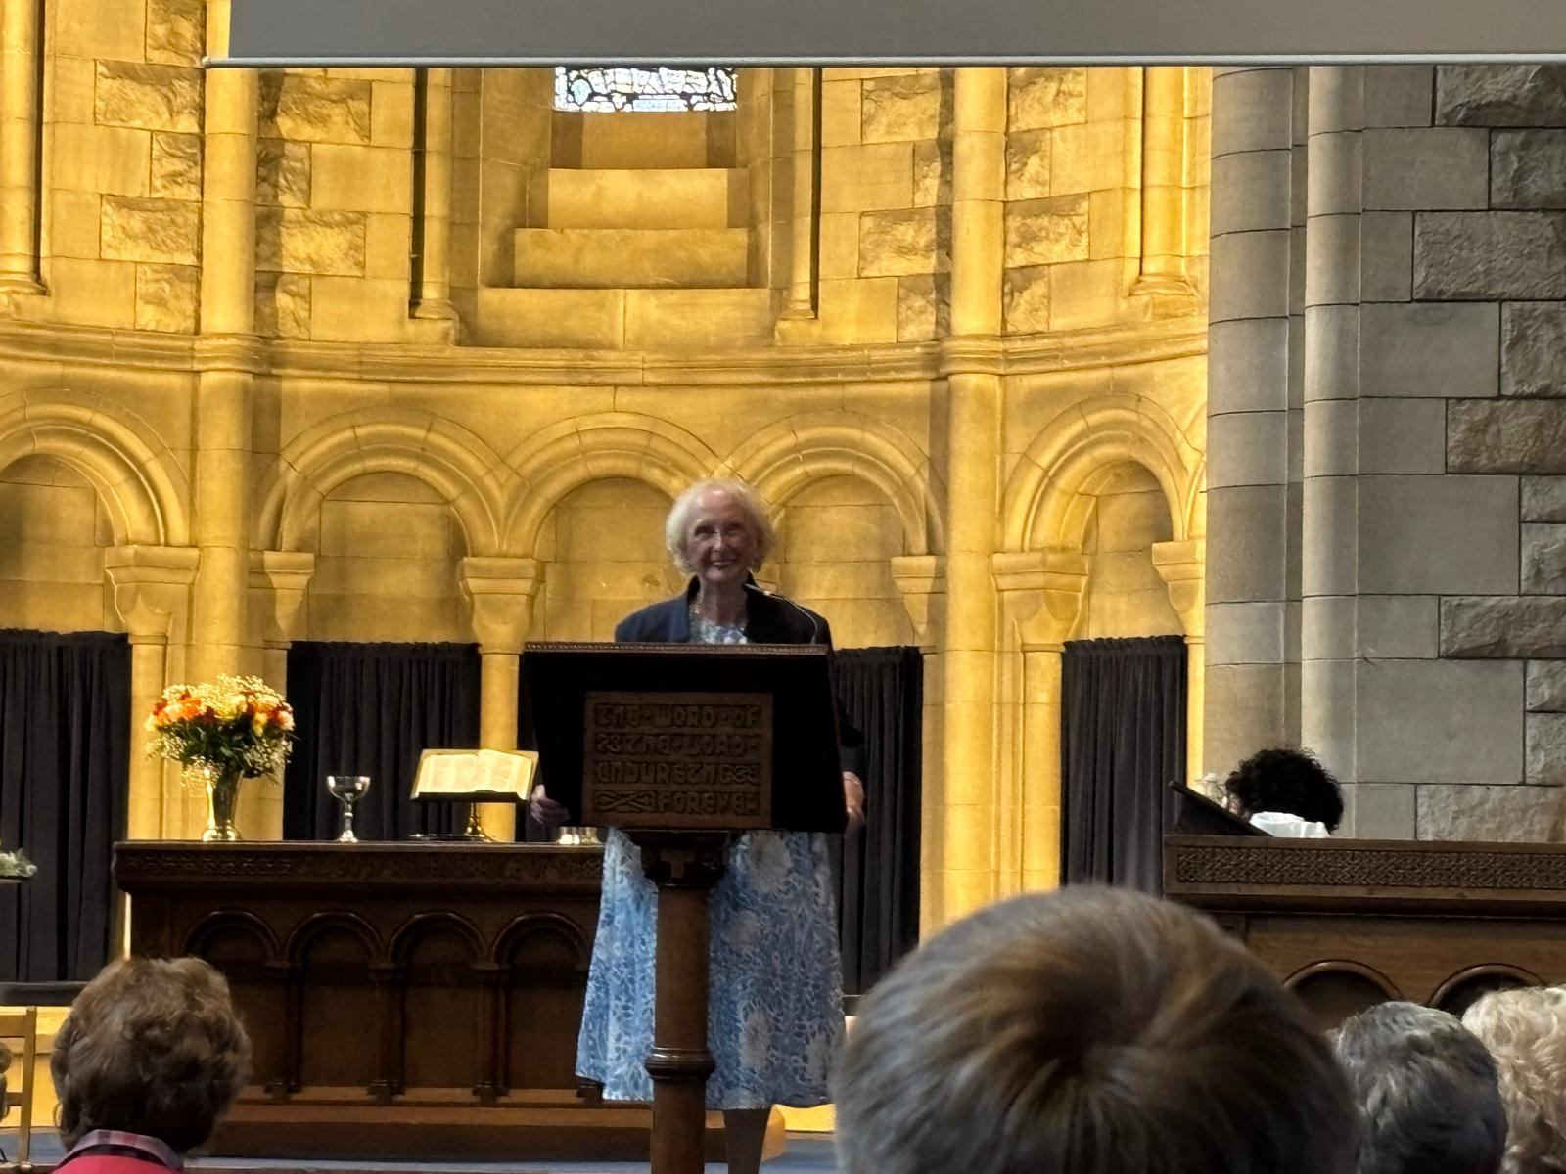

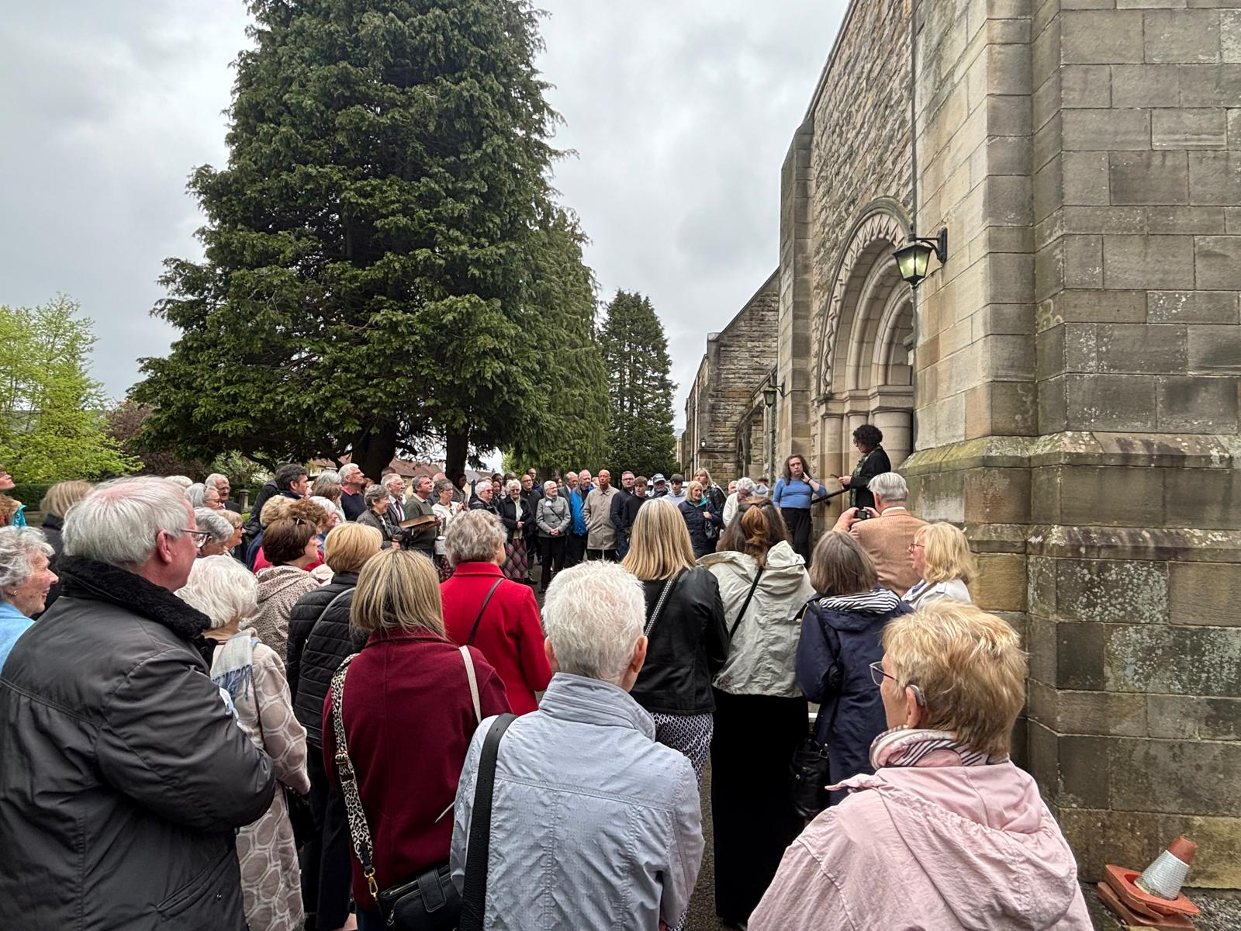

Rev Gillian Rooney, already minister to both churches in their linked charge, will now lead Glasgow Orchardlea Community Church into this new season of ministry and mission. Throughout the proceedings there was a strong sense that, while buildings and structures may change, the faith, fellowship and calling of God’s people continue strongly and faithfully.

The celebrations continued on Sunday 10 May, when the congregation gathered for its very first service as Glasgow Orchardlea Community Church. There was a genuine sense of excitement and joy as members worshipped together under their new name for the first time. The service reflected both gratitude for the past and enthusiasm for the future, as the newly united congregation looked ahead to the opportunities for worship, outreach and fellowship that this new chapter will bring.

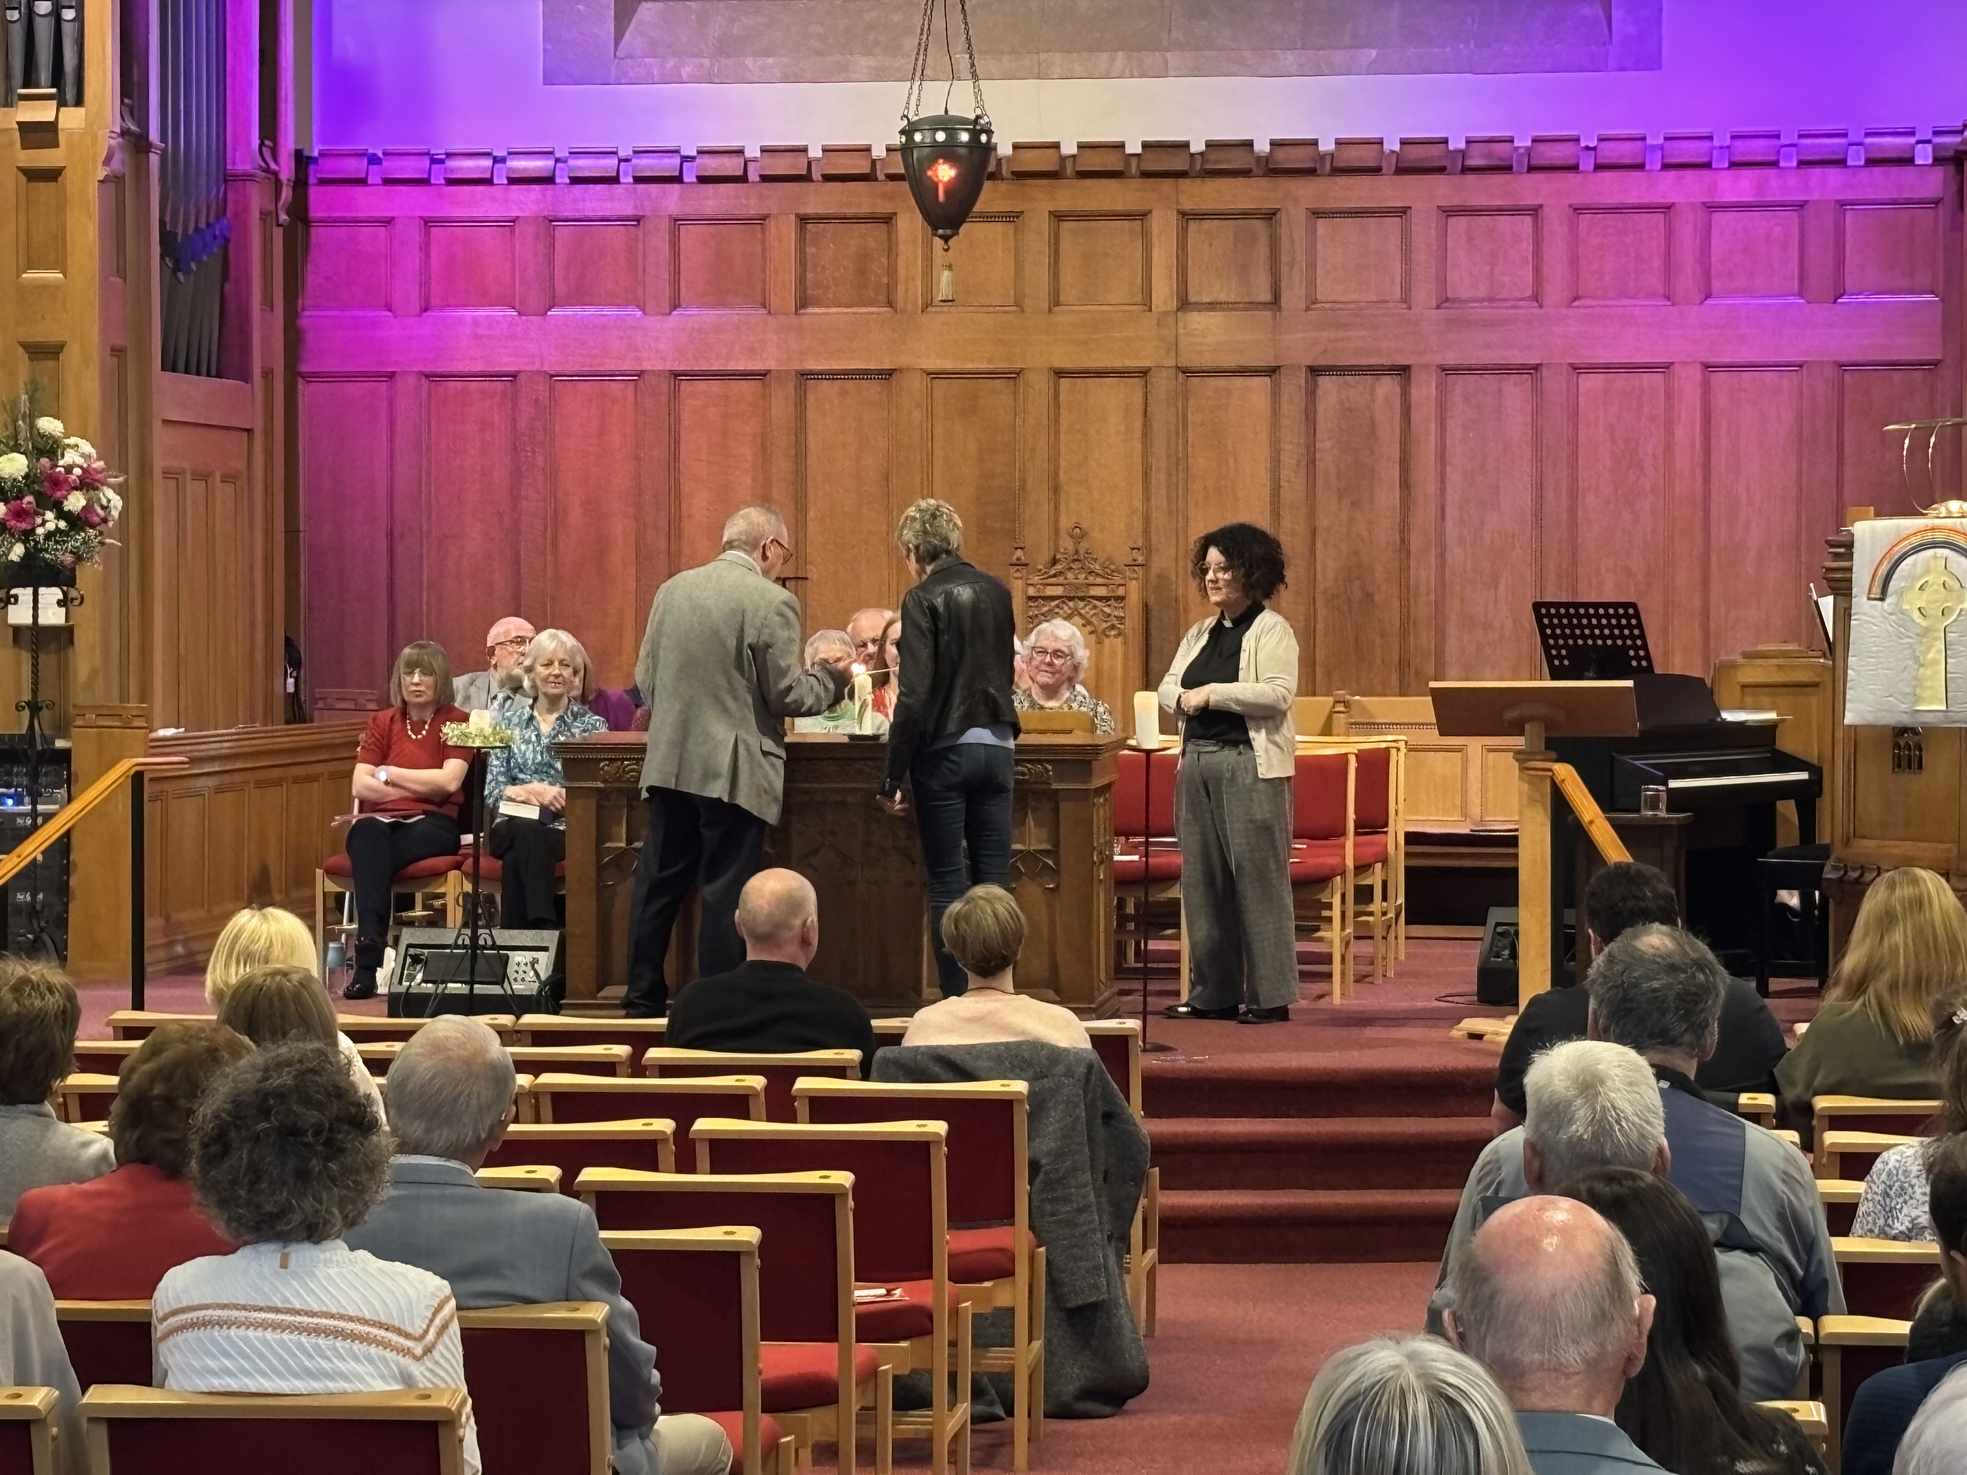

Following the service, members and guests enjoyed tea, coffee and a wonderful selection of cakes together, creating a warm and welcoming atmosphere. The time of fellowship gave everyone the opportunity to share stories, renew friendships and celebrate this landmark occasion in the life of the church. Grateful thanks were expressed to the Church Events Committee for their tremendous hard work in preparing such welcoming and memorable occasions.
While there was understandable sadness at the close of two historic congregations, the overwhelming feeling throughout both weekends was one of unity, gratitude and hopeful expectation for the future of Glasgow Orchardlea Community Church.

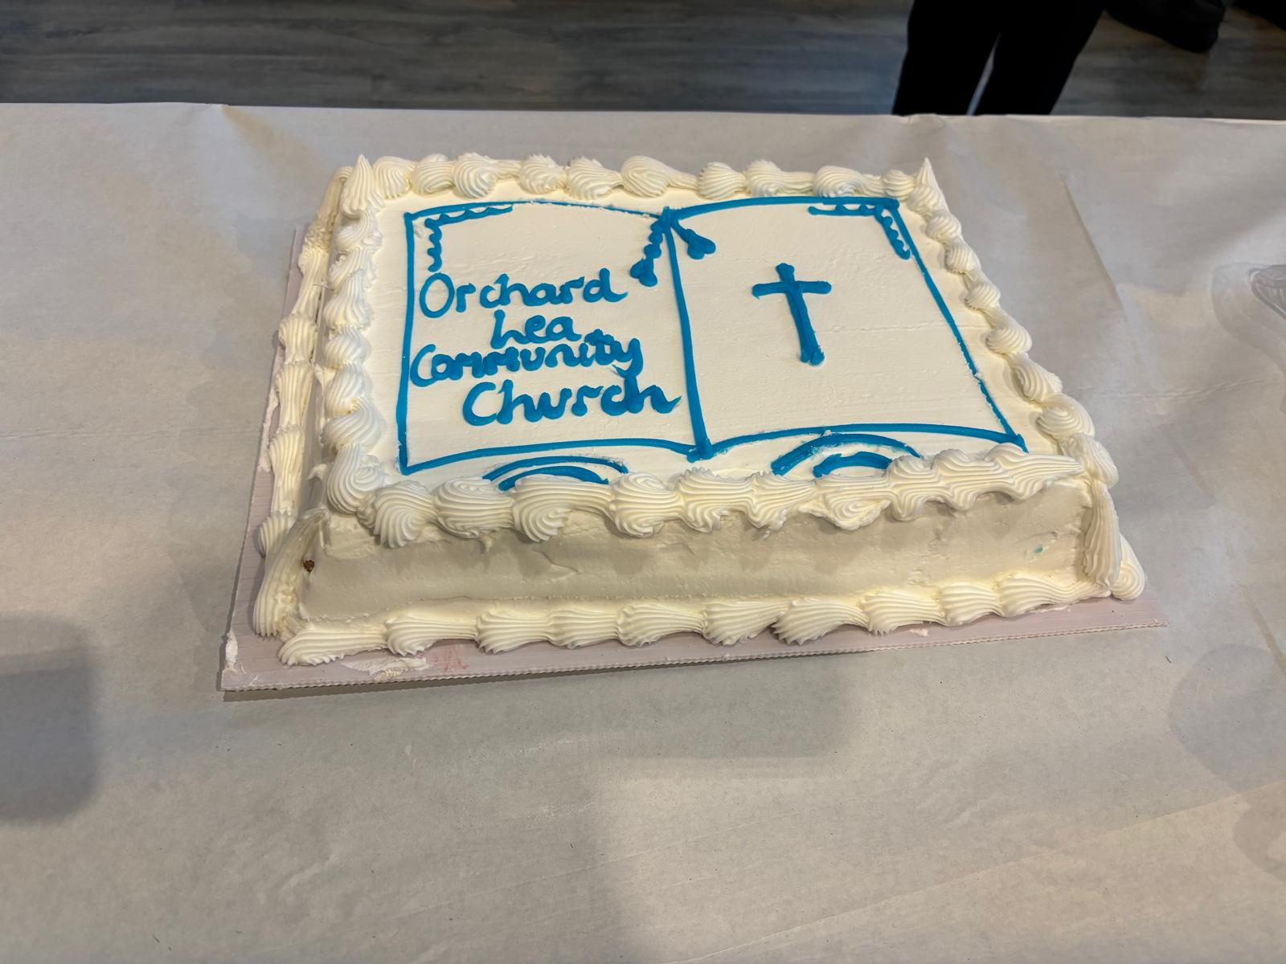

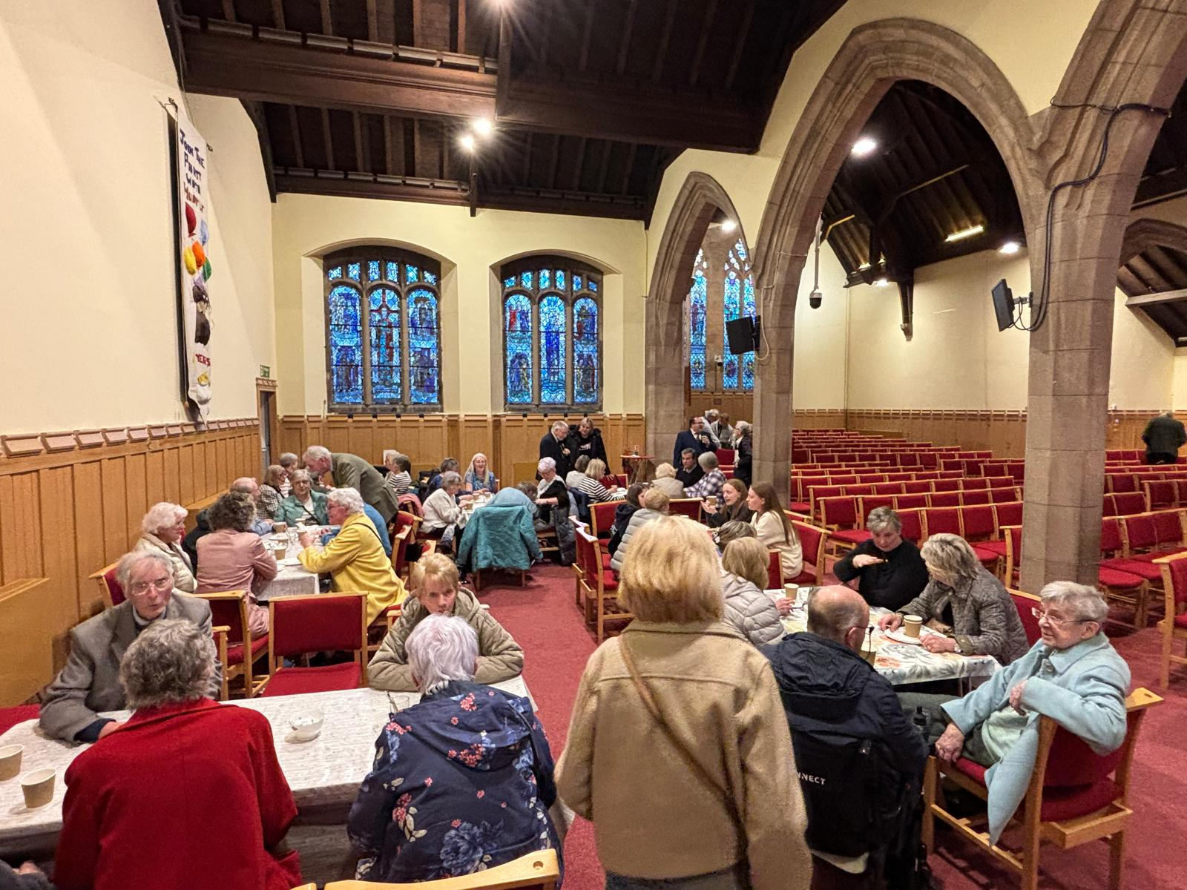

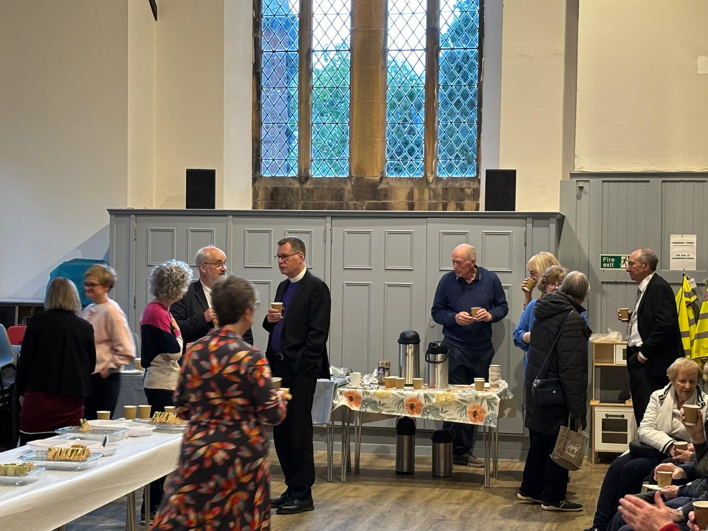

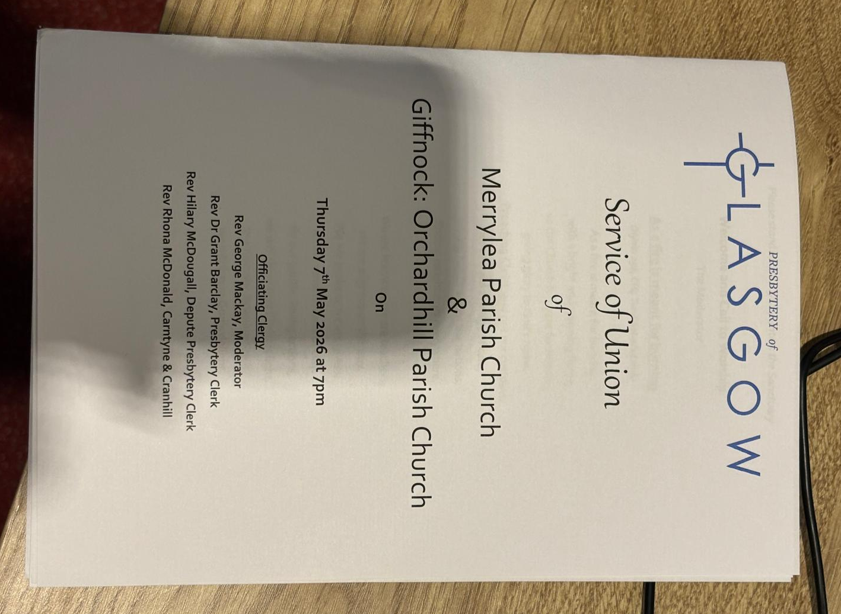

ONE PART OF THE BLACK DOOR SHOP: THE “MENS SHED” PROGRAMME
“Banding Together” is a skill-sharing programme includes practical skills. Many people lack confidence to undertake practical and creative activities involving hand work; we seek to give people opportunities to acquire such skills through woodworking.
Personal development through practical activities such as woodwork has a long and successful history in the Nordic countries, where the benefit to people’s self-esteem is well understood.
Practical workshop activities require careful attention by participants; the mental health benefits of this necessary ‘mindfulness’ are clear.

EXAMPLES OF PROJECTS COMPLETED

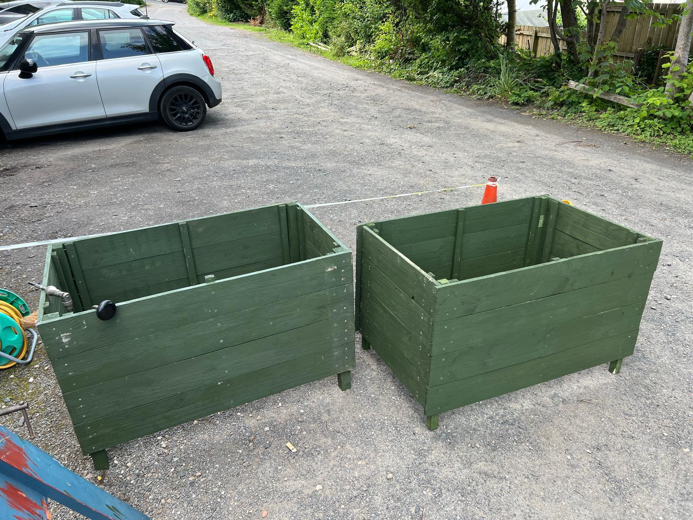

A person who stays in sheltered housing complex, mainly occupied by older people, over the last 20 years or so, obtained the help of like minded neighbours to grow plants, and provided a lovely display in planters for all residents to admire. The planters rotted and a plea for help was received at The Black Door Shop. We used this part of the project to allow students to develop the skills described above. They were delighted when her finished planters and a new potting table were put in their place in the community garden. The person who made the initial approach is very grateful that Black Door Shop volunteers have been able to help in her efforts to improve the living environment for her and her neighbours, from whom she has received positive feedback about the benefits they feel.

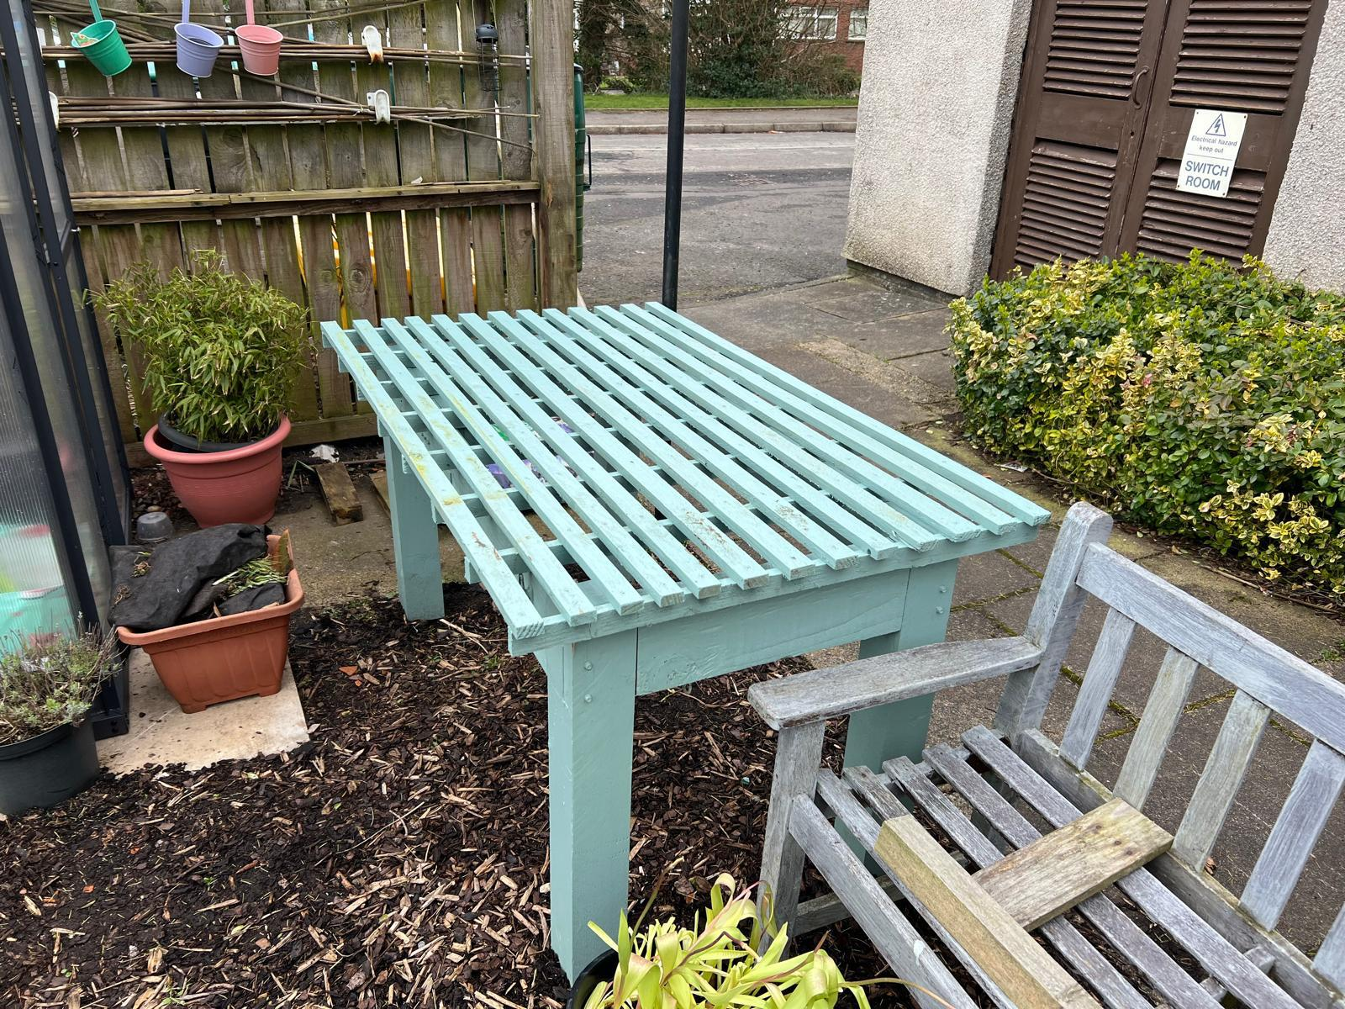

On being requested to make planters for a project at VAER at the Clarkston Community Garden, we arranged for three students to be involved in learning the skills as before, assembling lengths of timber in the correct widths and number of pieces These planters were built up so that they could be readily used by a person sitting or standing. Polina, who was present when the planters were delivered, commented on how good they were.
The Presbytery Clerk of Glasgow Rev Dr Grant Barclay sought our help to produce a frame from an older timber in which coloured glass would be inserted for a collaborative project he was working on. As the student on this project, he researched the type of timber required (also upcycled). Once obtained, it had to be cut to size and width using the band saw and mitre saw. Our student had to go though the same process of induction, and enjoyed his time on the project. He is greatly appreciative of the real sense of achievement obtained through hand-working skill development
One of the things we have learned is that one-to-one and small group learning is more successful than attempting larger groups, although in time we would like to develop workshops allowing wider participation.

A PACKED EASTER SUNDAY SERVICE

Easter 2026: the last joint Easter service of the linked congregations of Orchardhill and Merrylea. A bitter cold winter-spring day with wind, rain and snow. And a glorious morning of celebration and singing, of breakfast and baptism, and, quite simply, of the joy of the message that Jesus Is Alive!

Not even the very hardiest of souls would have risked our usual early service in the Peace Garden, so we worshipped instead in the Sanctuary, safe from the tail end of Storm Dave. 65 people enjoyed a short service of worship, hearing again the words of the Easter Story. And after so many years, we finally remember the tune of Gillian’s favourite Easter hymn, Up From The Grave He Arose!

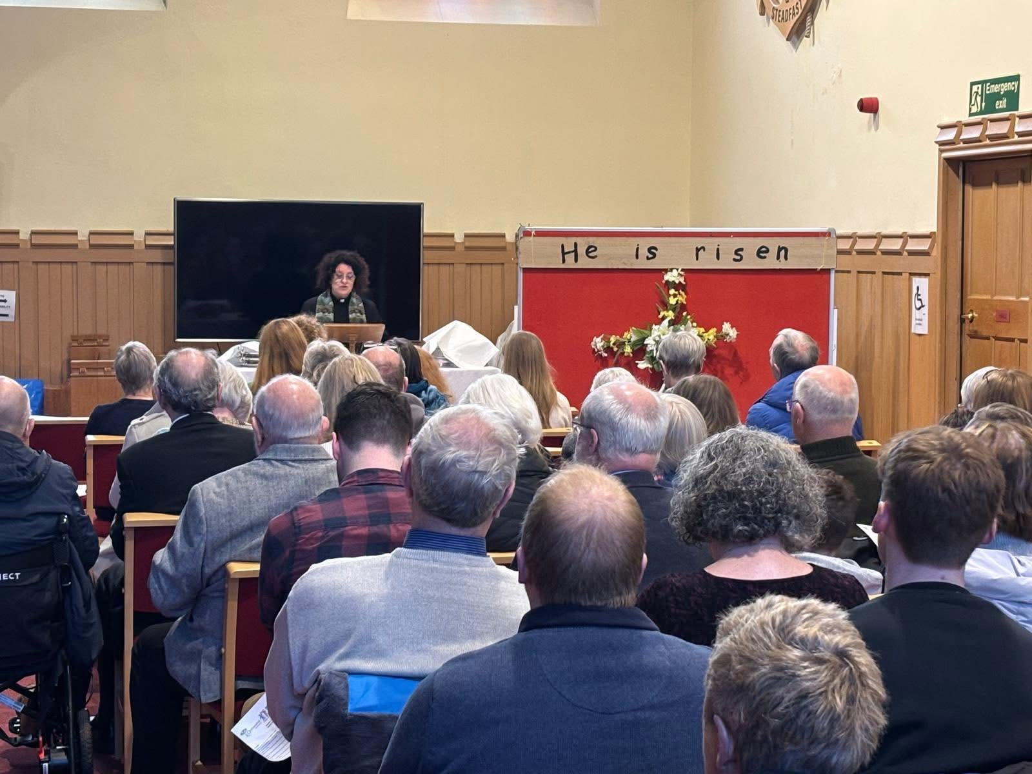

Many of those early worshippers stayed on for a delicious breakfast (thanks as always to the ladies in the kitchen for their hard work) and then it was time to go again.

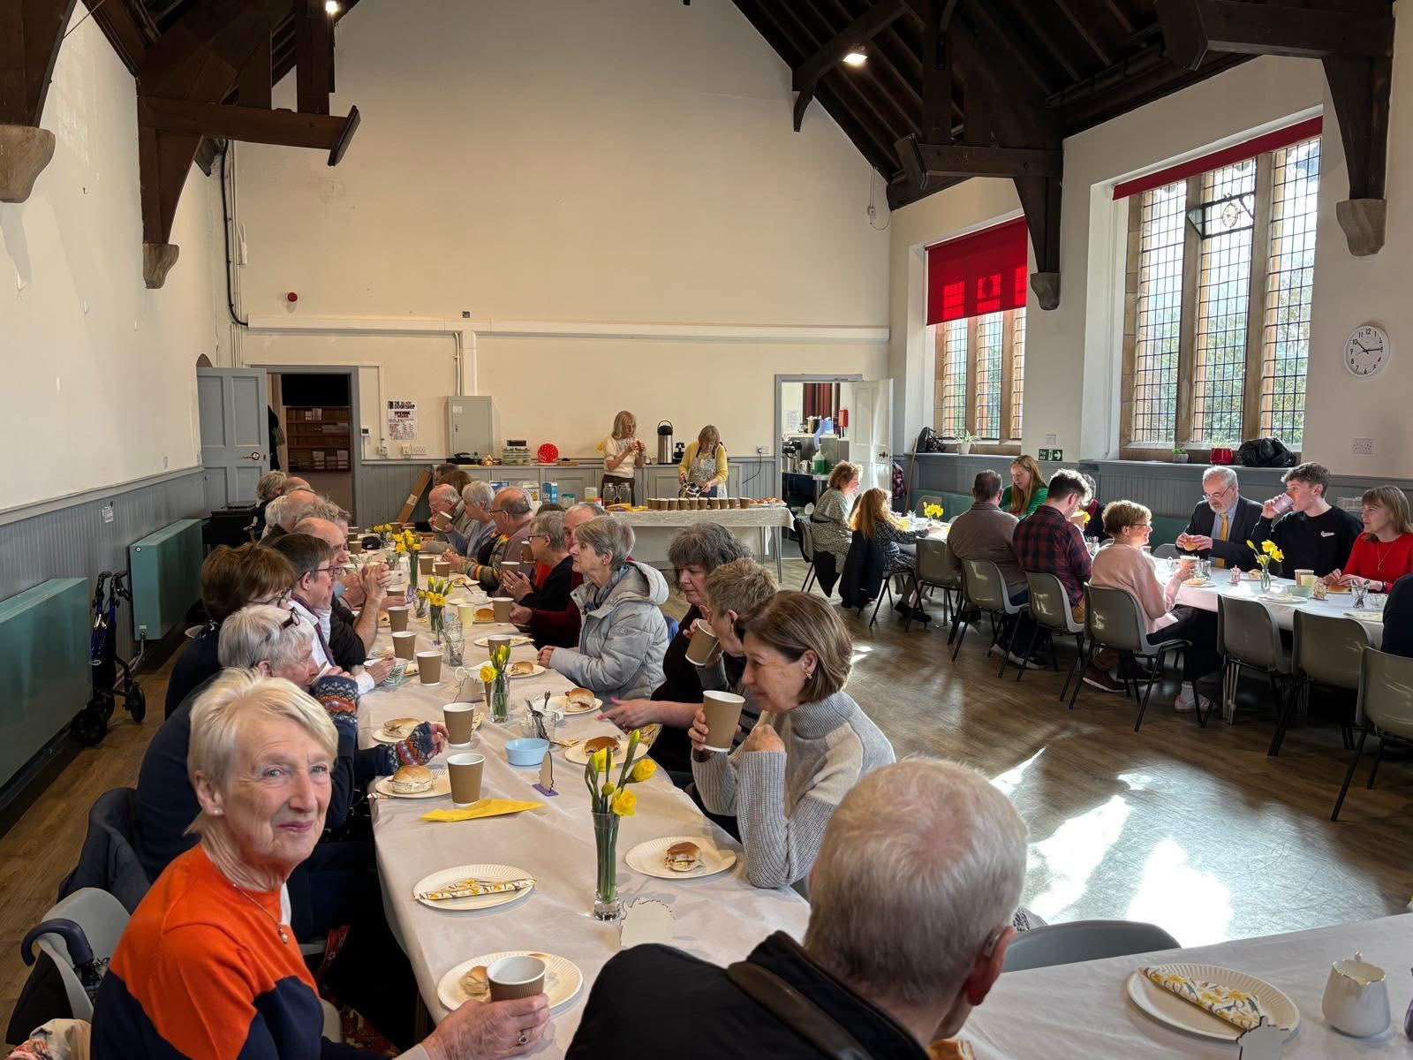

And even as the rain turned to snow, the crowd started to come in. On such a terrible day, we might have expected some people to stay at home. But an amazing 263 people came to worship, to celebrate the baptism of baby Sloane Grace, and to witness her mum, Amy, make profession of faith in the Church where she grew up.

With a packed Church, the singing was glorious. A brief surprise: Robert had never played at a Christening, and didn’t know the tune to The Lord Bless You and Keep You. So we sang ‘a cappella’ instead, and the sound of all those voices singing to a little baby was honestly spine-tingling.

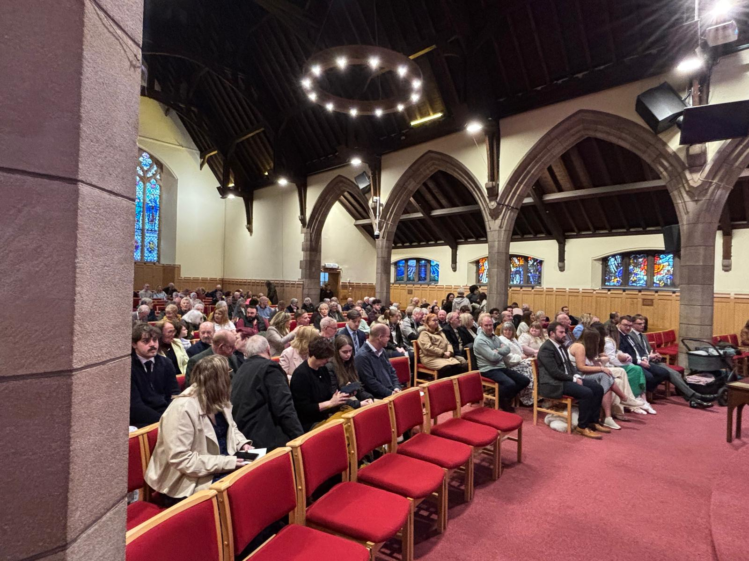

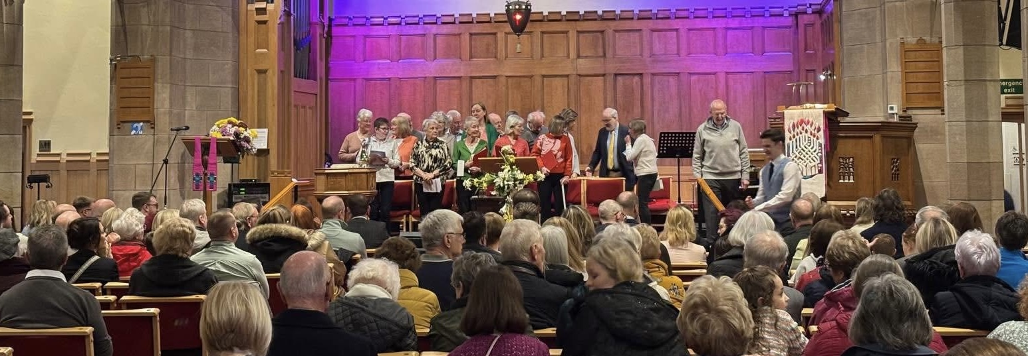

As we move forward in our Union, let’s hope Orchardlea Community Church can look forward to more Sundays with a packed Sanctuary, little children running about, and occasional thinking on our feet as things happen. And perhaps with a little less springtime snow.

Welcome Eilidh

We are delighted to share the good news that our recent application for funding from the national church has been successful. This funding will enable us to employ a Community Engagement and Faith Development Worker for the next three years.

Following a process of advertising, shortlisting and interviews, we are pleased to announce the appointment of Eilidh Macdonald to this new role. Eilidh is currently an elder at Cathcart Church of Scotland and brings with her a wealth of experience, enthusiasm and fresh ideas for how we might strengthen our connections with the wider community and world around us.

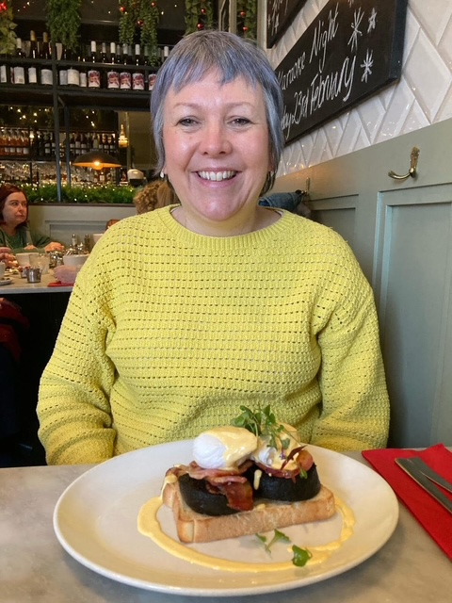

We hope that Eilidh will begin her work with us at the start of June, and there will be many opportunities for the congregation to get to know her in the months ahead.
Our prayer is that this new role will help us continue to share the good news of Jesus beyond the walls of our church buildings, building upon the many quiet and faithful ways in which members of the congregation are already serving and connecting with others. We look forward to discovering together what God is already doing among us and in our community.

Church Garden and Grounds

May has been a challenging month for the garden with low overnight temperatures and many downpours. Fortunately, most of the plants have survived unscathed, and, a year on from its inception, the Anniversary Garden is maturing.

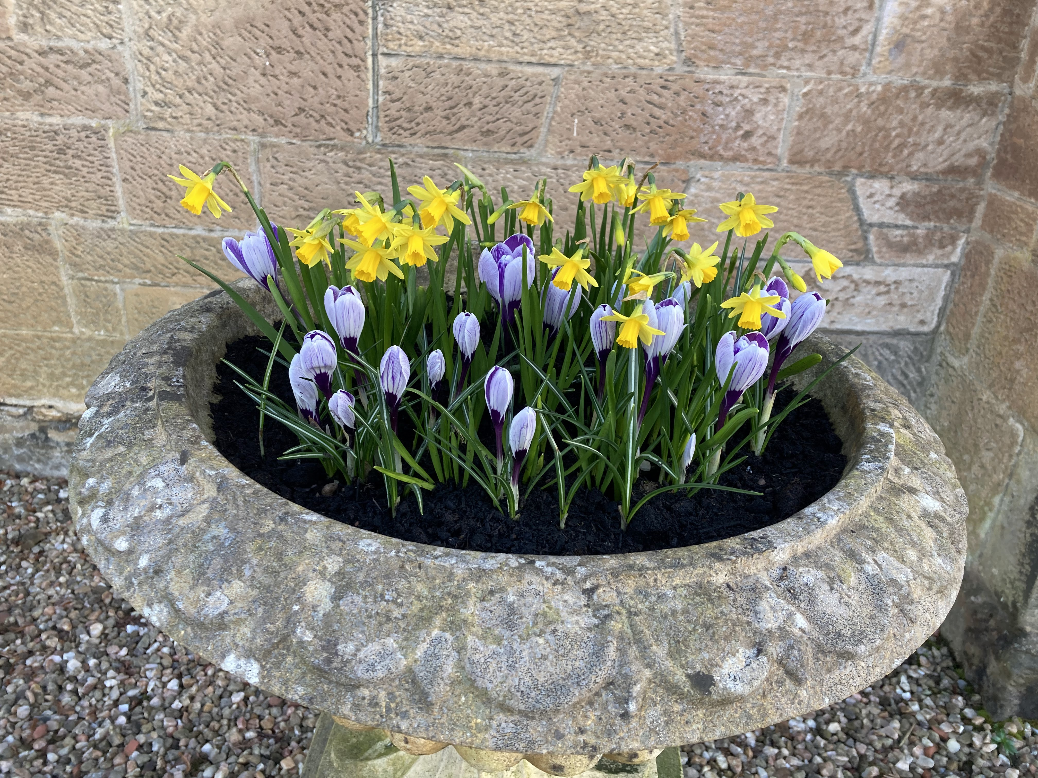
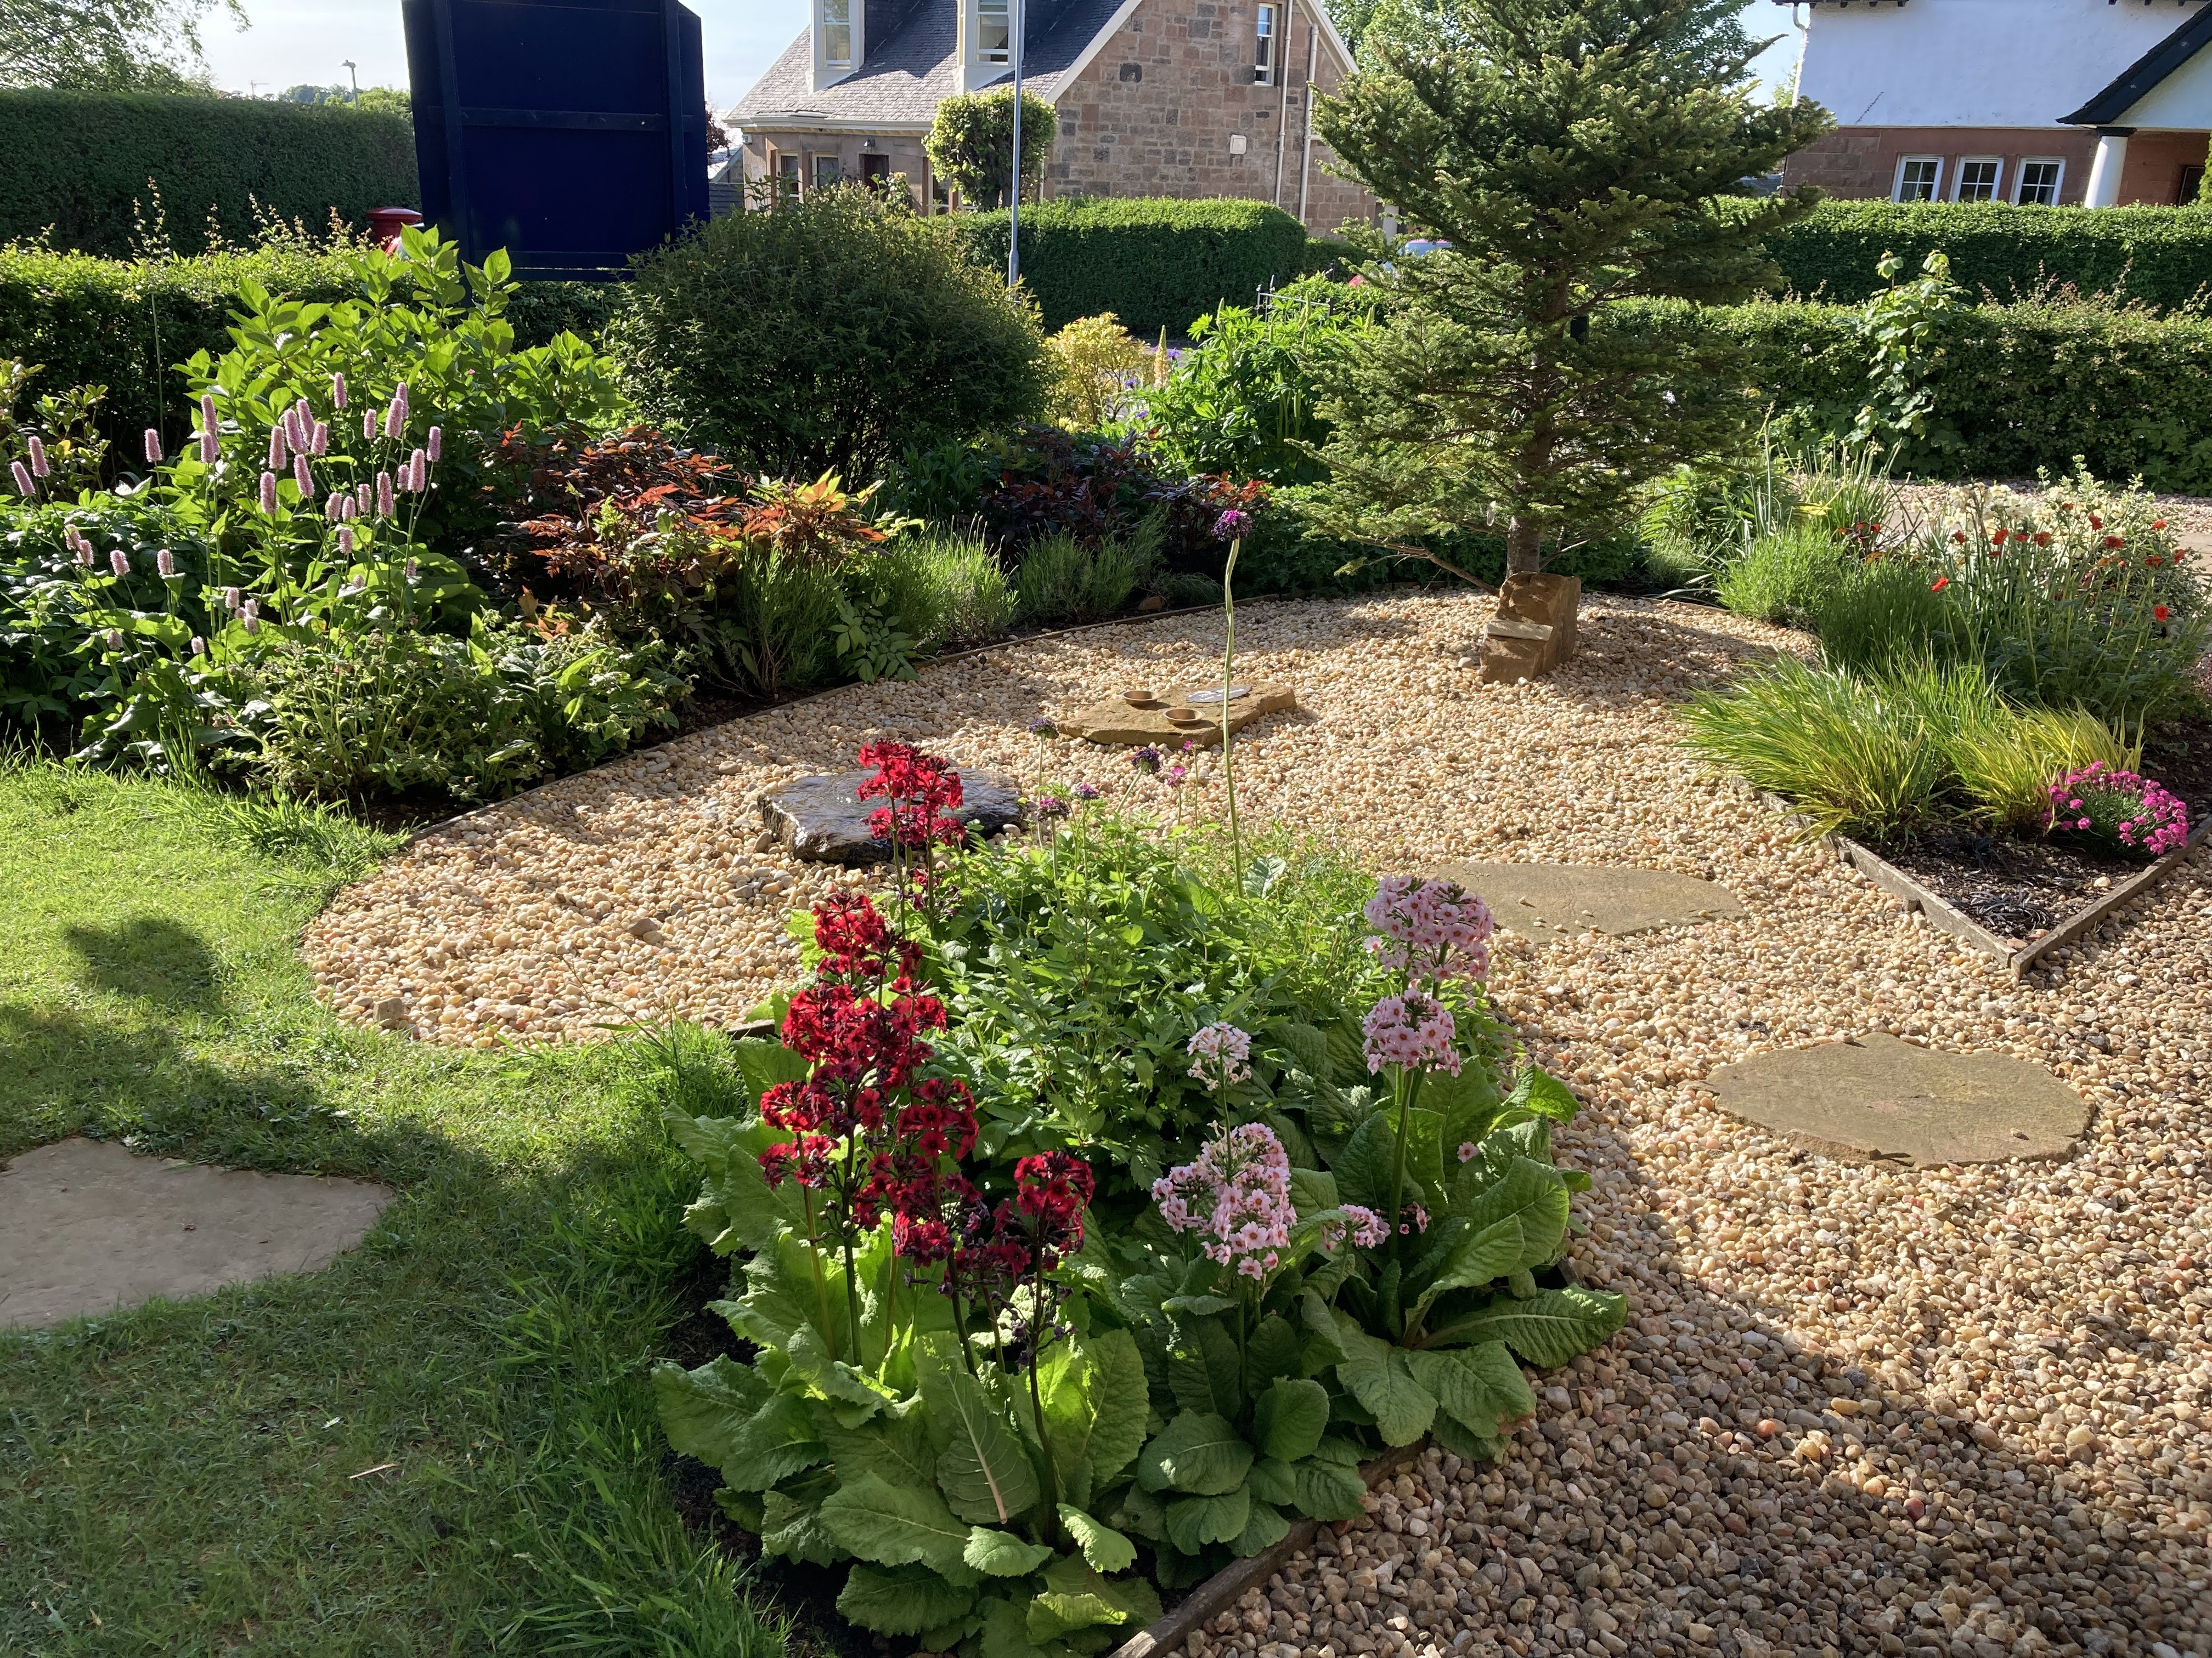

The garden group were delighted that the snowdrops, crocuses and narcissus provided early colour and pollen. When the leaves die back sufficiently, seeds will be sown in the pots and planters.

The group have been working away as usual on Thursday mornings, as well as taking time to chat at The Orchard. The Forsythia has been pruned in line with our thoughts on reducing shrub height for easier management.

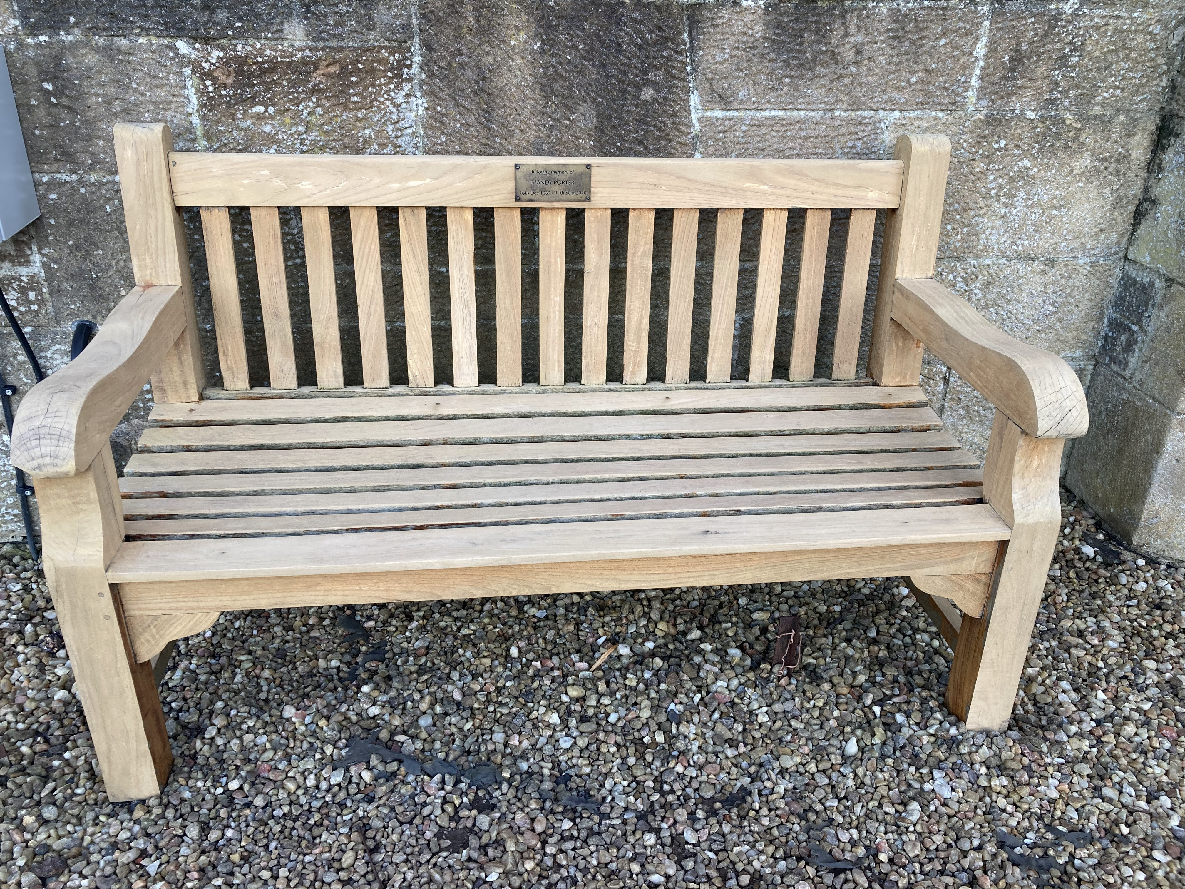

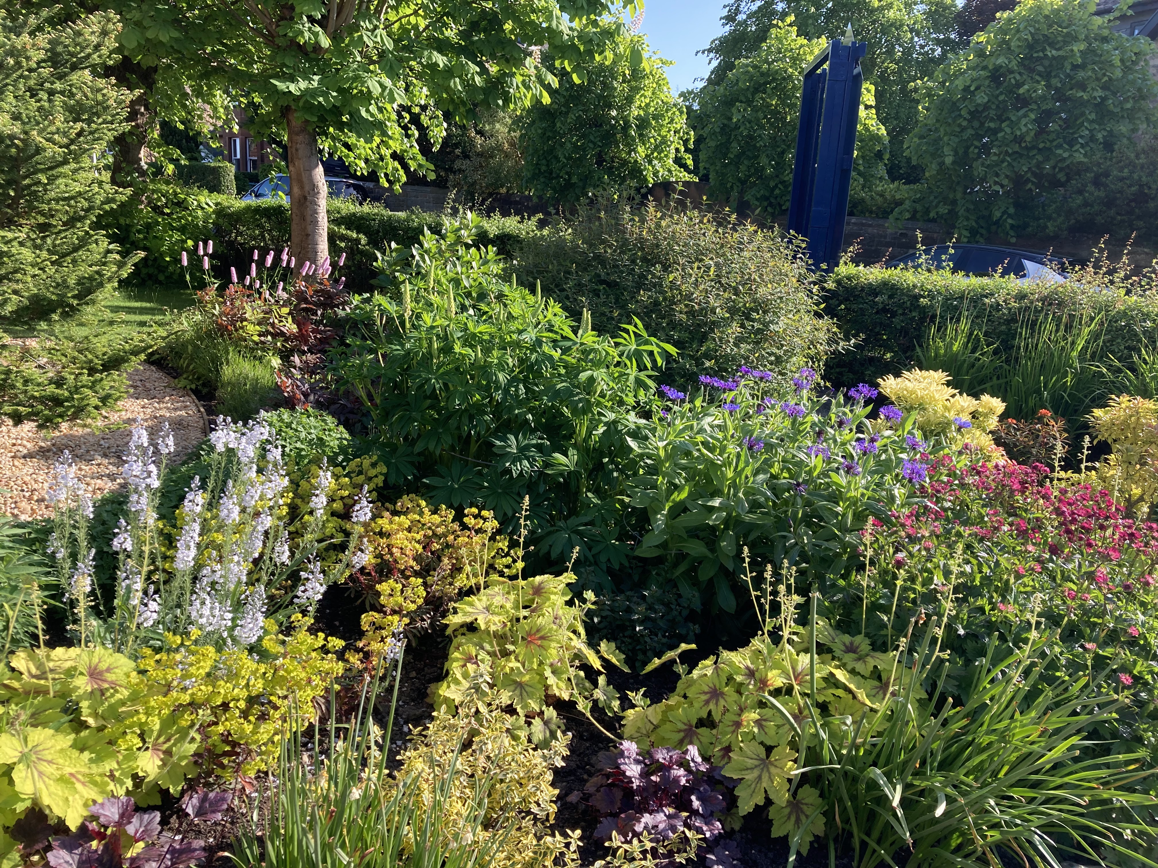

We would be delighted to welcome additional team members. No particular gardening skill is required, but enthusiasm, and a strong desire to nurture our grounds for future generations, is mandatory.

THE SON

A wealthy man and his son had a valuable collection of art and would often sit together and admire their great paintings.

When the Vietnam conflict broke out, the son went to war. He was very courageous and died in battle while rescuing another soldier. The father was notified and grieved greatly for his only son. A month later, just before Christmas, a young man arrived at the residence with a large package in his hands. He said, “Sir, you do not know me, but I am the soldier for whom your son gave his life. He saved many lives that day, and he was carrying me to safety when a bullet struck and he died instantly. He often talked of you and your love for art.” He held out the package. “I know this isn’t much as I’m not a great artist but I think your son would have wanted you to have this.” The father opened the package. It was a portrait of his son, painted by the young man. He stared in awe at the way the soldier had captured the personality of his son and he was so touched by it that his eyes welled up with tears. He thanked the young man and offered to pay for the picture. “Oh no Sir, I could never repay what your son did for me. It’s a gift.” The father hung the portrait so that every time visitors came to his home, he could show them the portrait of his son before he showed them his masterpieces.

The man died a few months later and there was to be a great auction of his goods. Many influential people gathered, excited at the opportunity to bid for one of the great paintings in his collection. On the platform at the start of the auction sat the painting of his son. The auctioneer started the sale by opening the bidding for this picture. “Who will bid for this lot?” One man at the back of the room shouted, “We want to see the famous paintings, skip this one.” But the auctioneer persisted “Will someone open the bidding? £200? £100? Another voice shouted angrily, “We didn’t come to buy this painting, get on with the real bids.” Still the auctioneer continued “The son! The son!! Who’ll take the son?”

Finally a voice came from the very back of the room. It was a long time gardener of the man and his son. Being a poor man, he called “£10”, for it was all he could afford. “We have £10, who will bid 20? Won’t someone give me £20? The crowd was becoming restive. They didn’t want the amateurish picture of the son, they wanted the more worthy investments for their collections. The auctioneer pounded his gavel. “Going, going SOLD for £10!”

Then the auctioneer laid down his gavel “I’m sorry, the auction is over. When I was called to conduct this auction, I was told of a secret stipulation in the will. I was not allowed to reveal it until this time. Only the painting of the son would be auctioned. Whoever bought the painting would inherit the entire estate, including all the paintings. The man who took the son gets everything.”
God sent his Son 2000 years ago and like the auctioneer he calls “The Son, the Son. Who’ll take the Son?”

Because you see, whoever takes the Son, takes everything!

Church WhatsApp Group

If you would like to be added to our new Orchardlea WhatsApp community for last minute church updates and social chat please send your mobile number to secretary@orchardlea.org.uk

OY! Orchardlea Youth News

Check Us Out on Our Socials

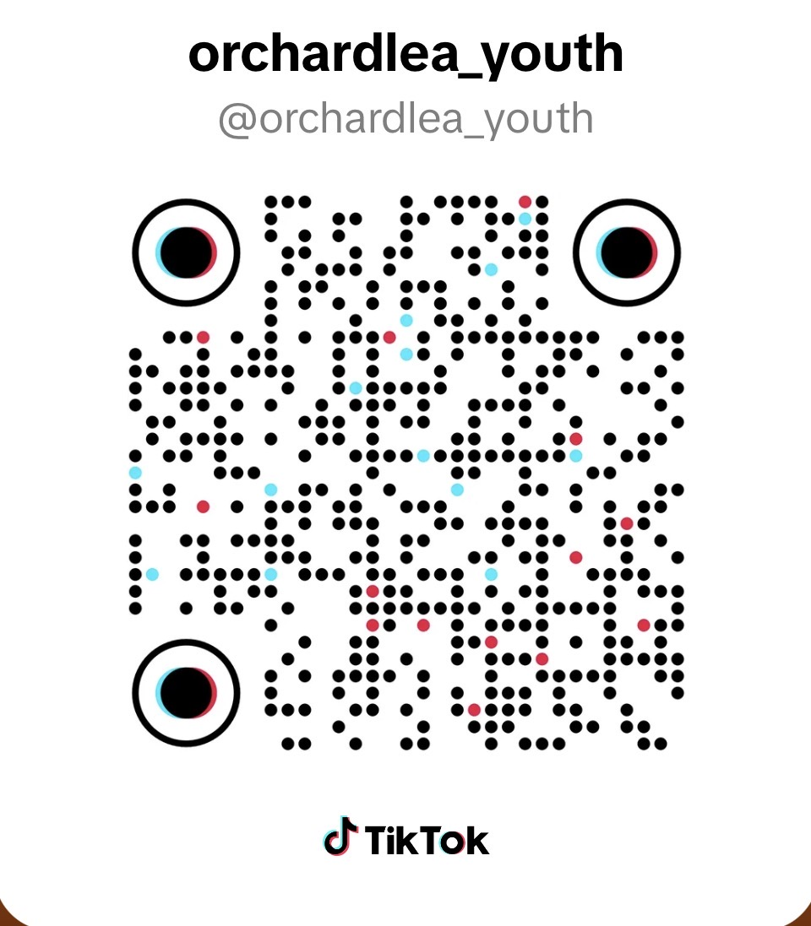


Instagram

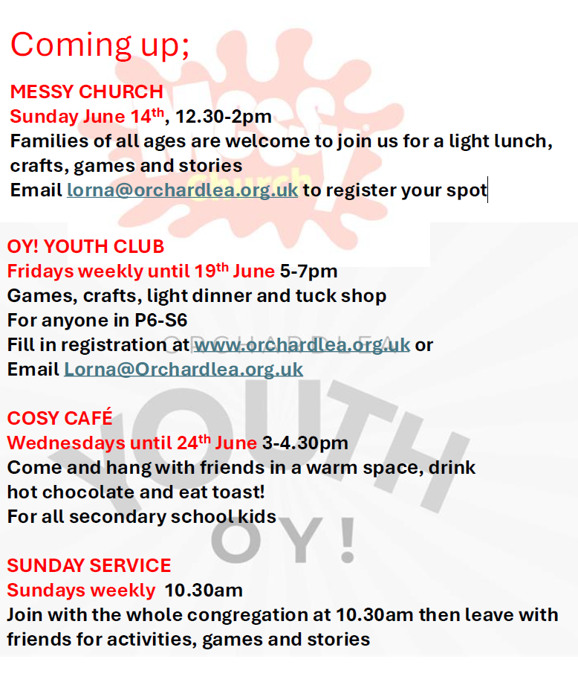

Ladies Book Group

Are you a keen reader of (mostly) contemporary fiction? And would you enjoy friendly chat - sometimes even book related - with a lovely group of ladies?
If this sounds like you, our book group might be what’s missing from your life. We meet about every six weeks at the home of any one of our members. Previously we have always met in the evening, but we are now trying to alternate afternoons/evenings.
Books are chosen by the group - so no pressure to be the one to choose! One of us puts together a shortlist of 5 or 6 books, we exclude anything anyone has read and take it from there.
If you’d like to know more, or just to talk about books, catch Linda Moir at coffee some Sunday, or call 07968 793437.

Bible Study Groups
Members and friends of Orchardlea have gathered, over the years, in groups at Church, or in our homes, to study sections of the Bible, and share hospitality and fellowship.
We currently have one study group who meet in the afternoon and another who meet in the evening – each group generally meets every 2-3 weeks.
Recent studies in the house groups have included Ephesians, the Lord's Prayer, the wonderful book of Ruth, in the Old Testament, and the Parables of Jesus in the New. We recently studied the Holy Spirit, and are presently working through the inspiring book of Psalms. To assist us, we use study guides suitable for those at any and all stages in their Christian journeys.
New participants are always welcome, and are invited to seek more information from our Minister, Rev. Gillian Rooney, or from Ian Cartlidge - ianjcartlidge@gmail.com

Family News, Announcements Etc.

We would like to include a section in The Record where you can share your news. This could be the arrival of a new baby, the graduation of a loved one, or the announcement of an engagement or marriage.

In addition to the joyful events, we would like to include a ‘remembrance’ section where we can publish tributes and life stories of deceased members of your family who were members or attendees of Orchardhill. Such information can act as important records for future generations. If you would like assistance in producing the articles, please let us know, and we can help with this.

To submit an article, please email to record-team@orchardhill.org.uk or hand in a hard copy to the office (a new Orchardlea email address is currently being set up).

Orchardlea Congregational Roll

Deaths

Margaret Watson

Well done thou good and faithful servant. Rest safe in the Lord.

Baptism

Sloane Grace Daughter of Amy and Ross
Gareth Griffiths

Profession of Faith

Amy Harvey
Gareth Griffiths

Transfer by Resolution of Kirk Session

Janet Benson

Articles for the Orchardlea Community News & Editorial Team

Readers are welcome to submit articles to the Orchardlea Community News Team to be considered for publication. Items should not exceed 500 words, and should report on events in the Church, publicise forthcoming events, or be of likely interest to the congregation.

It would be hugely appreciated if any articles could be in an editable format such as within the body of an email or in MS Word etc. Please avoid PDFs if at all possible.

Articles are not normally attributed to the Author.

Please send anything you’d like us to look at to: record-team@orchardhill.org.uk
(a new Orchardlea email address is currently being set up).

With this first issue of the Orchardlea Community News, the editorial team extends a warm welcome to David McLellan, formerly of Merrylea congregation and kirk session, who joins the former Orchardhill team.

In addition to David, the team comprises our Session Clerk, Ian Anderson, our Minister's husband, Mark Rooney, our Secretary, Karen Akins, Linda Moir and Ian Cartlidge.

Publication of the 'Record', since the Covid pandemic, has largely been in digital form, latterly with the Enews, and Dave Thomson, the Orchardlea webmaster, helps greatly in this regard.

Printed copies can be made available for those without digital access - please contact the Church office on 0141 638 3604 for a copy, or speak to one of the editorial team.

Volunteers for Media Desks

We are always looking for new volunteers to join the media team during our services. If you are interested in helping with the sound desk, presentation slides, or live streaming, we would love to hear from you.

Please contact the church office by emailing secretary@orchardlea.org.uk or speak to Bill Wallace or Dave Thomson before or after a service.

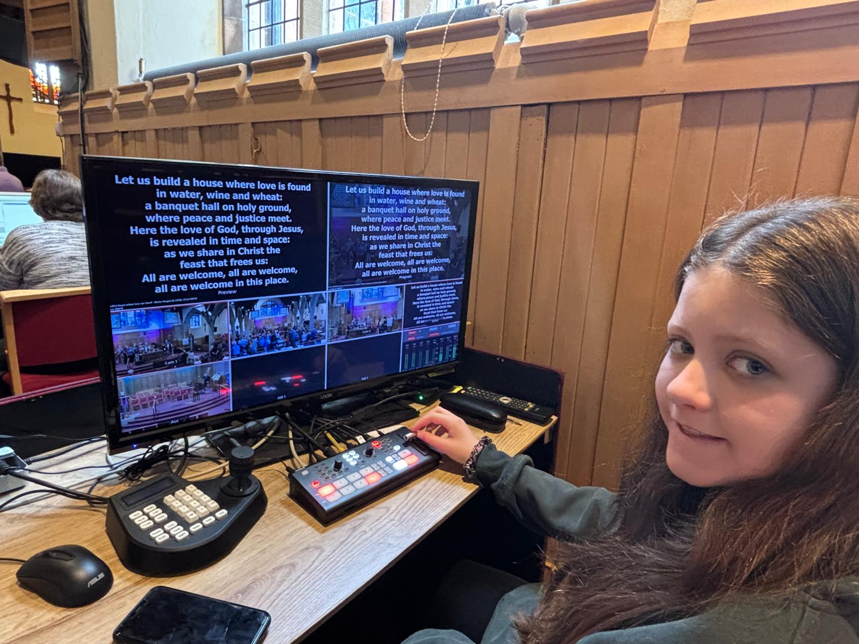

Orchardlea Community Church, Church Road, Giffnock Glasgow G46 6JR
phone 0141 638 3604
website: www.orchardlea.org.uk
email: secretary@orchardlea.org.uk

Orchardlea Community Church: Scottish Charity number SC 009774

